- Breast Cancer-1 dataset
Step(1): Copy the link (https://www.10xgenomics.com/datasets/human-breast-ca
ncer-block-a-section-1-1-standard-1-1-0) and open it in your browser. You will see the following page:
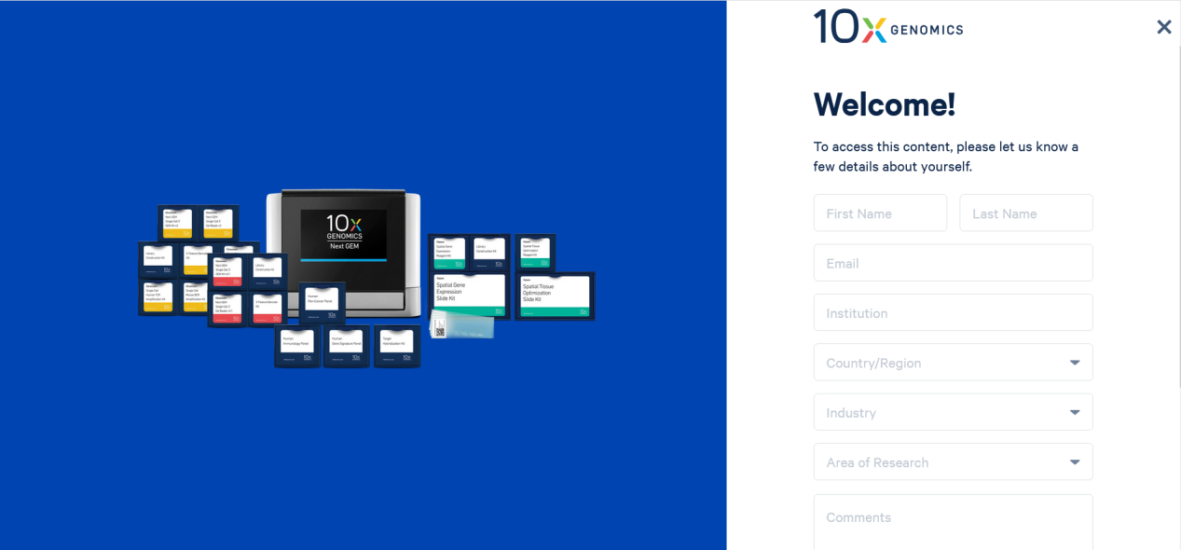
Step(2): Fill in the required personal information according to the prompts on the page opened in step (1). Here is an example of filling out:
First Name: Jiuxi
Last Name: Huang
Email: huangjiuxi@126.com
Institution: Henan Normal University
Country/Region: China/河南Henan
Industry: University
Area of Research: Genetic Disease
After filling out, please check the two option boxes at the bottom of the page. Then click the “Submit” button. The page will redirect to the following interface:
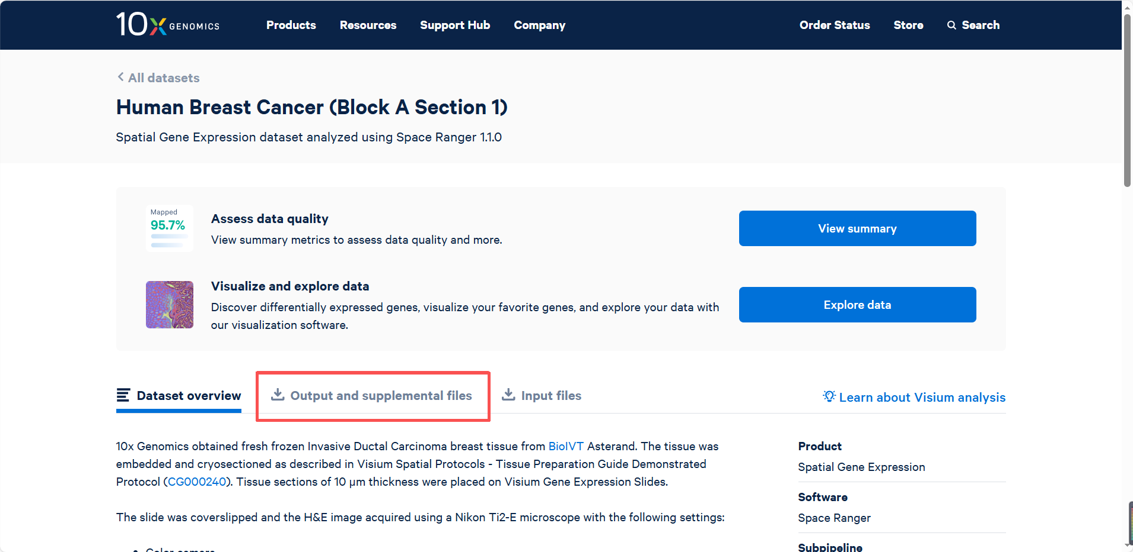
Step(3): On the page obtained in Step (2), click the “Output and supplemental files” option. You can then view and download the Breast Cancer-1 Dataset files, as shown in the following figure.
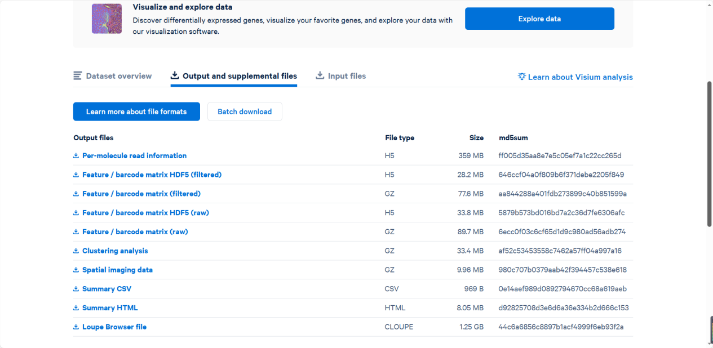
- Breast Cancer-2 dataset
The process of obtaining the Breast Cancer-2 dataset is similar to that of Breast Cancer-1 dataset. First, copy and open the link (https://www.10xgenomics.com/ datasets/human-breast-cancer-ductal-carcinoma-in-situ-invasive-carcinoma-ffpe-1-standard-1-3-0). Then, fill in your personal information on the page and submit the form. After submission, click the “Output and supplemental files” option to access the download interface for the Breast Cancer-2 dataset, as shown in the figure below.
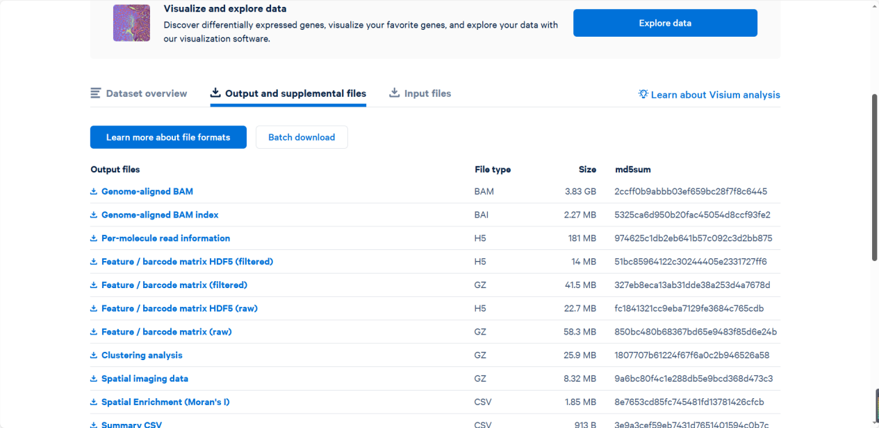
- Mouse Kidney Dataset
The process of obtaining the Mouse Kidney Dataset is similar to that of Breast Cancer-1 dataset. First, copy and open the link (https://www.10xgenomics.com/ datasets/mouse-kidney-section-coronal-1-standard-1-1-0). Then, fill in your personal information on the page and submit the form. After submission, click the “Output and supplemental files” option to access the download interface for the Breast Cancer-2 dataset, as shown in the figure below.
