Supplementary Material
Predicting loss of hepatitis B surface antigen and evaluating the durability of functional cure induced by pegylated interferon alpha: insights from a real-world study

Content
Supplementary Results
Supplementary Table1. Univariate logistic analysis affecting treatment response at 24 weeks.
Supplementary Table 2. Multifactorial stepwise logistic analysis affecting treatment response at 24 weeks.
Supplementary Table 3. Baseline information on subjects grouped according to 48-week treatment response or not.
Supplementary Table 4. Univariate logistic analysis affecting treatment response at 48 weeks.
Supplementary Table 5. Multifactorial stepwise logistic analysis affecting response to treatment at 48 weeks.
Supplementary Table 6. Baseline data table for subjects with or without HBsAg serologic reversal after Peg-IFN-α induced HBsAg loss.
Supplementary Figure 1: Area under ROC curve of different models.
Supplementary Figure 2: Scatter plots stratified by 24-week treatment response.
Supplementary Figure 3: Scatter plots stratified by 48-week treatment response.

Supplementary Results

A total of 265 subjects were included in the predictive analysis of treatment response for the 48-week regimen (Figure 1). Among them, 208 achieved HBsAg loss within the 48-week period, including 146 males and 62 females, with an average age of 38.9 years. Detailed baseline information of the subjects can be found in Supplementary Table 3. Comparing subjects who achieved HBsAg loss at 48 weeks to those who did not, the former had lower baseline HBsAg and HBV DNA levels, greater reductions in HBsAg and HBV DNA at 12 and 24 weeks, and a greater increase in anti-HBs levels at 24 weeks of treatment. Both groups showed some increase in ALT and AST levels and a decrease in total protein and total bilirubin levels at 12 and 24 weeks of treatment. The results of the univariate logistic analysis revealed that HBeAg positivity, baseline HBsAg and HBV DNA levels, HBsAg levels at the start 12 and 24 weeks of treatment, HBV DNA levels at 12 weeks of treatment, HBV DNA levels at 24 weeks of treatment , anti-HBs levels at 12 and 24 weeks of treatment, the change in HBsAg at 12 weeks compared to baseline, the change in HBV DNA at 12 weeks compared to baseline , the change in anti-HBs at 24 weeks compared to baseline and the change in AST at 12 weeks compared to baseline were significant predictors of response at the 48-week treatment mark (Supplementary Table 4 and Supplementary Table 5).
The area under the curve (AUC) of the logistic regression model was calculated, and the ROC curve was plotted to assess the predictive value of the metrics associated with interferon response (Supplementary Figure 1). Baseline HBsAg levels combined with nucleoside treatment predicted response at 48 weeks of treatment. The combination of baseline HBsAg levels and the decrease in HBsAg at 12 or 24 weeks of treatment further im-proved predictive efficacy (AUC: 0.902; 95% CI: 0.859-0.946).

Supplementary Table 1. Univariate Logistic Analysis Affecting Treatment Response at 24 Weeks
 | Odds Ratio (95% CI) | P value
Age，years | 1.254(0.818-1.922) | 0.300
Gender | 0.890(0.560-1.414) | 0.890
NAs | 1.538(0.992-2.385) | 0.054
HBeAg (+) | 0.052(0.007-0.388) | 0.004*
NAFLD | 0.781(0.475-1.285) | 0.330
Splenomegaly | 0.672(0.275-1.643) | 0.384
Cirrhosis | 0.654(0.130-3.296) | 0.607
Baselines
HBsAg (log₁₀ ng/mL) | 0.400 (0.317-0.506) | 0.000*
Anti-HBs (mIU/mL) | 1.005 (0.992- 1.018) | 0.476
Anti-HBe (log₁₀ NcU/mL) | 1.218(0.964-1.538) | 0.098
Anti-HBc (log₁₀ NcU/mL) | 2.410(1.079-5.385) | 0.032*
DNA (log₁₀ IU/mL) | 0.844(0.738-0.966) | 0.014*
AST (U/L) | 0.990(0.974-1.008) | 0.270
ALT (U/L) | 0.995(0.985-1.004) | 0.280
γ-GT (U/L) | 0.996(0.985-1.006) | 0.407
TBIL (umol /L) | 1.014(0.987-1.042) | 0.308
IBIL (umol /L) | 1.009(0.960-1.061) | 0.728
TP(g/L) | 0.992(0.934-1.054) | 0.795
Alb(g/L) | 0.983(0.922-1.047) | 0.591
12 Week
HBsAg (log₁₀ ng/mL) | 0.195(0.130-0.292) | 0.000*
Anti-HBs (mIU/mL) | 1.008(0.997-1.020) | 0.144
Anti-HBe (log₁₀ NcU/mL) | 1.078(0.815-1.427) | 0.598
Anti-HBc (log₁₀ NcU/mL) | 1.203(0.609-2.377) | 0.594
DNA (log₁₀ IU/mL) | 0.421(0.222-0.799) | 0.008*
AST (U/L) | 1.000(0.995-1.006) | 0.854
ALT (U/L) | 0.998(0.993-1.003) | 0.364
γ-GT (U/L) | 1.002(0.999-1.004) | 0.286
TBIL (umol /L) | 0.969(0.917-1.024) | 0.260
IBIL (umol /L) | 0.954(0.877-1.037) | 0.270
TP(g/L) | 1.004(0.946-1.066) | 0.895
Alb(g/L) | 0.944(0.879-1.013) | 0.112
Δ12 Week
ΔHBsAg | 3.107(2.297-4.203) | 0.000*
Δ Anti-HBs | 1.005(0.995-1.016) | 0.332
ΔAnti-HBc | 0.745(0.375-1.480) | 0.401
ΔAST | 1.002(0.997-1.007) | 0.427
ΔALT | 1.001(0.997-1.005) | 0.565
Δγ-GT | 1.002(0.999-1.006) | 0.163
ΔTBIL | 0.979(0.944-1.014) | 0.239
*P < 0.05 indicates statistical significance.
Supplementary Table 2. Multifactorial stepwise logistic analysis affecting treatment response at 24 weeks
 | Odds Ratio (95% CI) | P value
Model 1: Inclusion of only treatment baseline period variables
NAs | 1.879(1.109-3.181) | 0.019*
HBeAg (+) | 0.071(0.009-0.562) | 0.012*
HBsAg (log10 ng/mL) | 0.388(0.299-0.503) | 0.000*
DNA (log10 IU/mL) | 0.840(0.711-0.993) | 0.041*
Model 2: Inclusion of variables at treatment baseline and at 12 weeks of treatment
HBeAg (+) | 0.112(0.013-1.013) | 0.051
HBsAg (log10 ng/mL) | 0.210(0.133-0.332) | 0.000*
DNA (log10 IU/mL) | 0.770(0.615-0.965) | 0.023*
ΔHBsAg (log10 ng/mL) | 5.912(3.578-9.769) | 0.000*
*P < 0.05 indicates statistical significance.
Supplementary Table 3. Baseline information on subjects grouped according to 48-week treatment response or not.
 | All | 48W no response | 48W response | P value
N | 265 | 57 | 208 | -
Gender，female(%) | 75 (28.4%) | 13 (22.8%) | 62 (30.0%) | 0.372
Age，years(mean±SD) | 38.63±8.09 | 37.47 (7.47%) | 38.95 (8.24%) | 0.223
NAs (%) | 151 (60.2%) | 28 (50.9%) | 123 (62.8%) | 0.153
HBeAg (+) (%) | 11 (4.3%) | 7 (12.7%) | 4 (2.0%) | 0.002*
NAFLD (%) | 81 (36.8%) | 20 (44.4%) | 61 (34.9%) | 0.310
Cirrhosis (%) | 4 (1.8%) | 2 (4.3%) | 2 (1.1%) | 0.403
Splenomegaly (%) | 13 (5.9%) | 5 (10.9%) | 8 (4.5%) | 0.203
Baseline treatment
HBsAg (log₁₀ ng/mL) | 1.99±1.11 | 2.81±0.90 | 1.77±1.06 | <0.001*
Anti-HBs (mIU/mL) | 2.51±19.25 | 0.62±1.35 | 3.03±21.69 | 0.407
Anti-HBe (log₁₀ NcU/mL) | 1.41±0.97 | 1.20±1.12 | 1.47±0.92 | 0.065
Anti-HBc (log₁₀ NcU/mL) | 2.06±0.31 | 2.01±0.30 | 2.07±0.31 | 0.206
DNA (log₁₀ IU/mL) | 1.03±1.58 | 1.44±1.92 | 0.92±1.46 | 0.028*
AST (U/L) | 25.34±12.15 | 27.49±16.42 | 24.66±10.43 | 0.165
ALT (U/L) | 29.31±24.18 | 32.38±28.86 | 28.34±22.53 | 0.318
γ-GT (U/L) | 26.16±18.71 | 26.49±17.90 | 26.05±19.02 | 0.890
TBIL (umol /L) | 13.50±9.78 | 12.08±4.84 | 13.95±10.87 | 0.255
TP(g/L) | 77.36±3.95 | 77.40±3.39 | 77.35±4.12 | 0.941
12 weeks of treatment
HBsAg (log₁₀ ng/mL) | 0.80±1.45 | 2.28±1.27 | 0.34±1.18 | <0.001*
Anti-HBs (mIU/mL) | 6.51±30.50 | 0.78±1.73 | 8.23±34.60 | 0.151
Anti-HBe (log₁₀ NcU/mL) | 1.40±0.87 | 1.18±1.02 | 1.46±0.81 | 0.055
Anti-HBc (log₁₀ NcU/mL) | 2.06±0.36 | 2.03±0.41 | 2.07±0.34 | 0.542
DNA (log₁₀ IU/mL) | 0.14±0.58 | 0.32±0.90 | 0.09±0.44 | 0.006*
AST (U/L) | 66.99±48.76 | 56.10±39.73 | 70.39±50.91 | 0.097
ALT (U/L) | 70.10±60.77 | 65.18±57.82 | 71.63±61.78 | 0.550
γ -GT (U/L) | 81.51±77.12 | 70.45±52.98 | 84.97±83.12 | 0.288
TBIL (umol /L) | 11.44±4.46 | 12.18±5.65 | 11.20±4.01 | 0.218
TP (log₁₀ g/L) | 74.36±4.22 | 74.85±3.36 | 74.21±4.45 | 0.392
24 weeks of treatment
HBsAg (ng/mL) | -0.20±1.41 | 1.23±1.23 | -0.73±1.06 | <0.001*
Anti-HBs (mIU/mL) | 12.85±27.63 | 1.32±2.48 | 17.02±31.20 | 0.001*
Anti-HBe (log₁₀ NcU/mL) | 1.44±0.90 | 1.39±1.02 | 1.45±0.86 | 0.688
Anti-HBc (log₁₀ NcU/mL) | 2.00±0.39 | 1.95±0.44 | 2.02±0.36 | 0.243
DNA (log₁₀ IU/mL) | 0.08±0.43 | 0.19±0.72 | 0.05±0.30 | 0.024*
AST (U/L) | 56.51±40.88 | 54.32±45.58 | 57.38±39.03 | 0.665
ALT (U/L) | 52.33±51.20 | 62.57±60.92 | 48.25±46.43 | 0.105
γ-GT (U/L) | 83.19±97.43 | 72.89±55.89 | 87.30±109.63 | 0.393
TBIL (umol /L) | 9.99±3.95 | 10.00±4.25 | 9.99±3.84 | 0.986
TP (g/L) | 74.76±8.53 | 74.79±10.13 | 74.75±7.85 | 0.976
Change from baseline at 12 weeks
ΔHBsAg (log₁₀ ng/mL) | 1.24±1.03 | 0.63±0.75 | 1.43±1.03 | <0.001*
ΔAnti-HBs (mIU/mL) | 3.51±30.35 | 0.16±1.57 | 4.52±34.54 | 0.405
ΔAnti-HBe (log₁₀ NcU/mL) | -0.02±0.37 | 0.06±0.50 | -0.05±0.32 | 0.080
ΔAnti-HBc (log₁₀ NcU/mL) | -0.02±0.36 | 0.02±0.43 | 2.66±1.16 | 0.391
ΔAST (U/L) | 41.96±50.36 | 26.39±31.79 | 47.35±54.46 | 0.031*
ΔALT (U/L) | 43.50±60.22 | 31.60±49.78 | 47.62±63.12 | 0.170
Δγ-GT (U/L) | 56.88±75.08 | 41.75±39.32 | 62.17±83.59 | 0.161
ΔTBIL (umol /L) | -2.08±9.46 | -1.59±4.37 | -2.25±10.70 | 0.718
ΔTP (g/L) | -3.14±4.25 | -2.70±3.35 | -3.30±4.53 | 0.474
Change from baseline at 24 weeks
ΔHBsAg (log₁₀ ng/mL) | 2.39±1.22 | 1.62±1.04 | -0.03±0.33 | <0.001*
ΔAnti-HBs (mIU/mL) | 11.91±27.48 | 0.73±2.63 | 15.92±31.05 | 0.001*
ΔAnti-HBe (log10 NcU/mL) | 0.04±0.59 | 0.04±0.65 | 0.03±0.57 | 0.938
ΔAnti-HBc (log10 NcU/mL) | -0.04±0.39 | -0.06±0.43 | -0.04±0.37 | 0.790
ΔAST (U/L) | 31.15±35.17 | 29.61±40.30 | 31.87±32.71 | 0.735
ΔALT (U/L) | 25.52±41.23 | 33.66±55.94 | 21.68±31.75 | 0.126
Δγ-GT (U/L) | 56.70±84.18 | 50.12±48.74 | 59.80±96.58 | 0.546
ΔTBIL (umol /L) | -3.90±10.63 | -2.73±4.18 | -4.45±12.56 | 0.395
ΔTP (g/L) | -2.37±6.70 | -3.10±10.09 | -2.03±4.30 | 0.398
*P < 0.05 indicates statistical significance.
Supplementary Table 4. Univariate Logistic Analysis Affecting Treatment Response at 48 Weeks.
 | OR (95% CI) | P value
Age，years | 0.691(0.348-1.373) | 0.291
Gender | 1.024(0.986-1.063) | 0.223
NAs | 1.625(0.889-2.969) | 0.115
HBeAg (+) | 0.139(0.039-0.495) | 0.002*
NAFLD | 0.669(0.344-1.301) | 0.236
Cirrhosis | 0.253(0.035-1.846) | 0.175
Splenomegaly | 0.390(0.121-1.256) | 0.115
Baseline treatment
HBsAg (log10 ng/mL) | 0.343(0.236-0.498) | 0.000*
Anti-HBs (mIU/mL) | 1.069(0.905-1.262) | 0.433
Anti-HBe (log₁₀ NcU/mL) | 1.315(0.980-1.766) | 0.068
Anti-HBc (log₁₀ NcU/mL) | 1.794(0.721-4.466) | 0.209
DNA (log₁₀ IU/mL) | 0.825(0.694-0.982) | 0.030*
AST (U/L) | 0.983(0.960-1.008) | 0.177
ALT (U/L) | 0.994(0.981-1.006) | 0.322
γ-GT (U/L) | 0.999(0.982-1.016) | 0.889
TBIL (umol /L) | 1.034(0.976-1.094) | 0.257
TP(g/L) | 0.997(0.917-1.083) | 0.940
Treatment for 12 weeks
HBsAg (log₁₀ ng/mL) | 0.330(0.237-0.459) | 0.000*
Anti-HBs (mIU/mL) | 1.234(1.022-1.489) | 0.028*
Anti-HBe (log₁₀ NcU/mL) | 1.445(0.988-2.114) | 0.058
Anti-HBc (log₁₀ NcU/mL) | 1.327(0.536-3.285) | 0.541
DNA (log₁₀ IU/mL) | 0.537(0.372-0.883) | 0.012*
AST (U/L) | 1.008(0.998-1.018) | 0.106
ALT (U/L) | 1.002(0.996-1.008) | 0.549
γ-GT (U/L) | 1.003(0.997-1.009) | 0.293
TBIL (umol /L) | 0.956(0.889-1.028) | 0.227
TP(g/L) | 0.964(0.887-1.048) | 0.390
Treatment for 24 weeks
HBsAg (log₁₀ ng/mL) | 0.207(0.122-0.352) | 0.000*
Anti-HBs (mIU/mL) | 1.232(1.074-1.413) | 0.003*
Anti-HBe (log₁₀ NcU/mL) | 1.078(0.749-1.552) | 0.686
Anti-HBc (log₁₀ NcU/mL) | 1.626(0.717-3.687) | 0.244
AST (U/L) | 1.002(0.993-1.011) | 0.664
ALT (U/L) | 0.995(0.989-1.001) | 0.125
γ-GT (U/L) | 1.002(0.997-1.007) | 0.404
TBIL (umol /L) | 0.999(0.917-1.089) | 0.986
TP(g/L) | 0.999(0.960-1.040) | 0.976
Change from baseline at 12 weeks
ΔHBsAg (log₁₀ ng/mL) | 2.904(1.770-4.764) | 0.000*
ΔAnti-HBs (mIU/mL) | 1.006(0.992-1.020) | 0.406
ΔAnti-HBe (log₁₀ NcU/mL) | 0.483(0.205-1.134) | 0.095
ΔAnti-HBc (log₁₀ NcU/mL) | 0.654(0.249-1.720) | 0.389
ΔAST (U/L) | 1.012(1.001-1.024) | 0.038*
ΔALT (U/L) | 1.005(0.998-1.013) | 0.172
Δγ-GT (U/L) | 1.005(0.998-1.012) | 0.174
ΔTBIL (umol /L) | 0.991(0.943-1.042) | 0.721
ΔTP (g/L) | 0.967(0.884-1.058) | 0.471
Change from baseline at 24 weeks
ΔHBsAg (log₁₀ ng/mL) | 2.283(1.618-3.221) | 0.000*
ΔAnti-HBs (mIU/mL) | 1.160(1.043-1.290) | 0.006*
ΔAnti-HBe (log₁₀ NcU/mL) | 0.977(0.554-1.724) | 0.937
ΔAnti-HBc (log₁₀ NcU/mL) | 1.127(0.470-2.703) | 0.789
ΔAST (U/L) | 1.002(0.991-1.013) | 0.733
ΔALT (U/L) | 0.993(0.984-1.002) | 0.138
Δγ-GT (U/L) | 1.002(0.996-1.007) | 0.552
ΔTBIL (umol /L) | 0.978(0.928-1.032) | 0.418
ΔTP(g/L) | 1.023(0.968-1.081) | 0.415
*P < 0.05 indicates statistical significance.

Supplementary Table 5. Multifactorial stepwise logistic analysis affecting response to treatment at 48 weeks
 | OR (95% CI) | P value
Model 1: Inclusion of only treatment baseline period variables
NAs | 2.860(1.308-6.254) | 0.008*
Baseline HBsAg (log10 ng/mL) | 0.351(0.230-0.536) | 0.000*
Model 2: Inclusion of variables at treatment baseline and at 12 weeks of treatment
Baseline HBsAg (log10 ng/mL) | 0.254(0.126-0.512) | 0.000*
ΔHBsAg (log10 ng/mL) | 3.582(1.788-7.179) | 0.000*
Model 3: Inclusion of variables at treatment baseline and at 24 weeks of treatment
Baseline HBsAg (log10 ng/mL) | 0.177(0.077-0.405) | 0.000*
ΔHBsAg (log10 ng/mL) | 5.654(2.488-12.848) | 0.000*
*P < 0.05 indicates statistical significance.

Supplementary Table 6. Baseline data table for subjects with or without rehabilitation for 48 weeks
 | All | Persistent response over 48 weeks (65 cases) | Seroconversion within 48 weeks (36 cases) | P value
Age，years | 40.54±8.04 | 40.91±7.25 | 39.89±9.38 | 0.545
Age > 50 years | 16 (15.8%) | 7 (10.8%) | 9 (25.0%) | 0.112
Gender，female | 29 (28.7%) | 18 (27.7%) | 11 (30.6%) | 0.940
NAs (%) | 67 (66.3%) | 50 (76.9%) | 17 (47.2%) | 0.005*
Baseline HBeAg positivity | 1 (1.0%) | 1 (1.5%) | 0 (0.0%) | 1.000
Combined NAFLD | 33 (32.7%) | 20 (30.8%) | 13 (36.1%) | 0.744
Combined cirrhosis | 2 (2.0%) | 2 (3.1%) | 0 (0.0%) | 0.751
Combined splenomegaly | 4 (4.0%) | 4 (6.2%) | 0 (0.0%) | 0.324
Duration of IFN consolidation >12 weeks after response | 51 (50.5%) | 39 (60.0%) | 12 (33.3%) | 0.018*
Hepatitis B vaccination after HBsAg clearance | 78 (77.2%) | 50 (76.9%) | 28 (77.8%) | 1.000
Serological indicators at baseline treatment
HBsAg (log₁₀ ng/mL) | 1.83±1.07 | 1.90±1.14 | 1.71±0.94 | 0.399
Anti-HBs (mIU/mL) | 3.74±26.06 | 5.37±32.43 | 0.80±1.75 | 0.401
Anti-HBe (log₁₀ NcU/mL) | 1.57±0.96 | 1.48±0.99 | 1.73±0.88 | 0.217
Anti-HBc (log₁₀ NcU/mL) | 2.08±0.36 | 2.11±0.31 | 2.00±0.42 | 0.145
Serological indicators at cessation of PEG-IFN-alpha therapy
Anti-HBs (mIU/mL) | 71.50±89.97 | 102.17±96.76 | 16.11±33.21 | <0.001*
Anti-HBe (log₁₀ NcU/mL) | 1.57±0.76 | 1.50±0.79 | 1.70±0.68 | 0.187
Anti-HBc (log₁₀ NcU/mL) | 1.99±0.42 | 1.99±0.38 | 2.00±0.49 | 0.846
*P<0.05 indicates statistical significance.

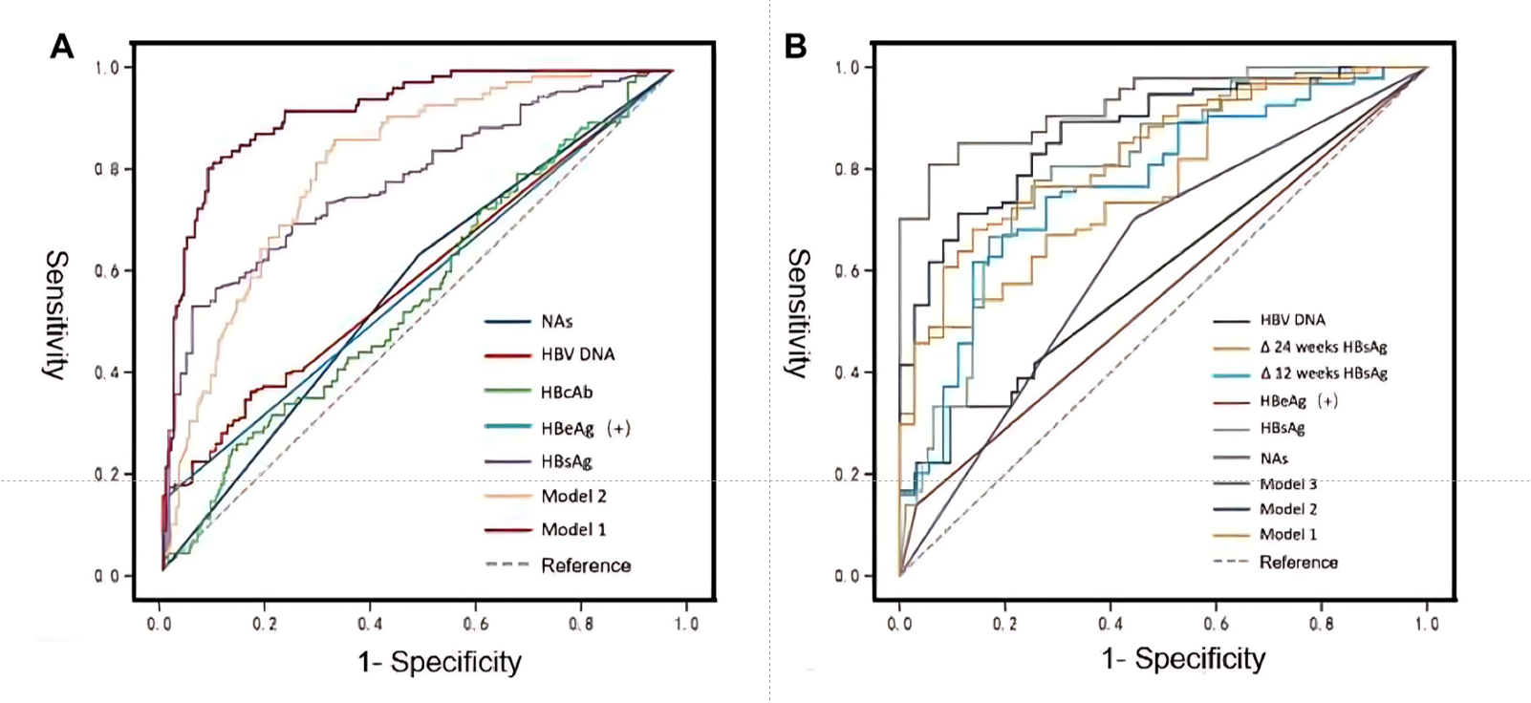 Supplementary Figure 1: Area under ROC curve of different models. a) Model 1 consisted of treated nucleoside +HBeAg positive + baseline HBsAg+ baseline HBV DNA; Model 2 was HBeAg positive + baseline HBsAg + baseline HBV DNA+ΔHBsAg. b) Model 1 was nucleoside therapy + baseline HBsAg; Model 2 was baseline HBsAg + ΔHBsAg at 12 weeks; Model 3 was baseline HBsAg + ΔHBsAg at 24 weeks.

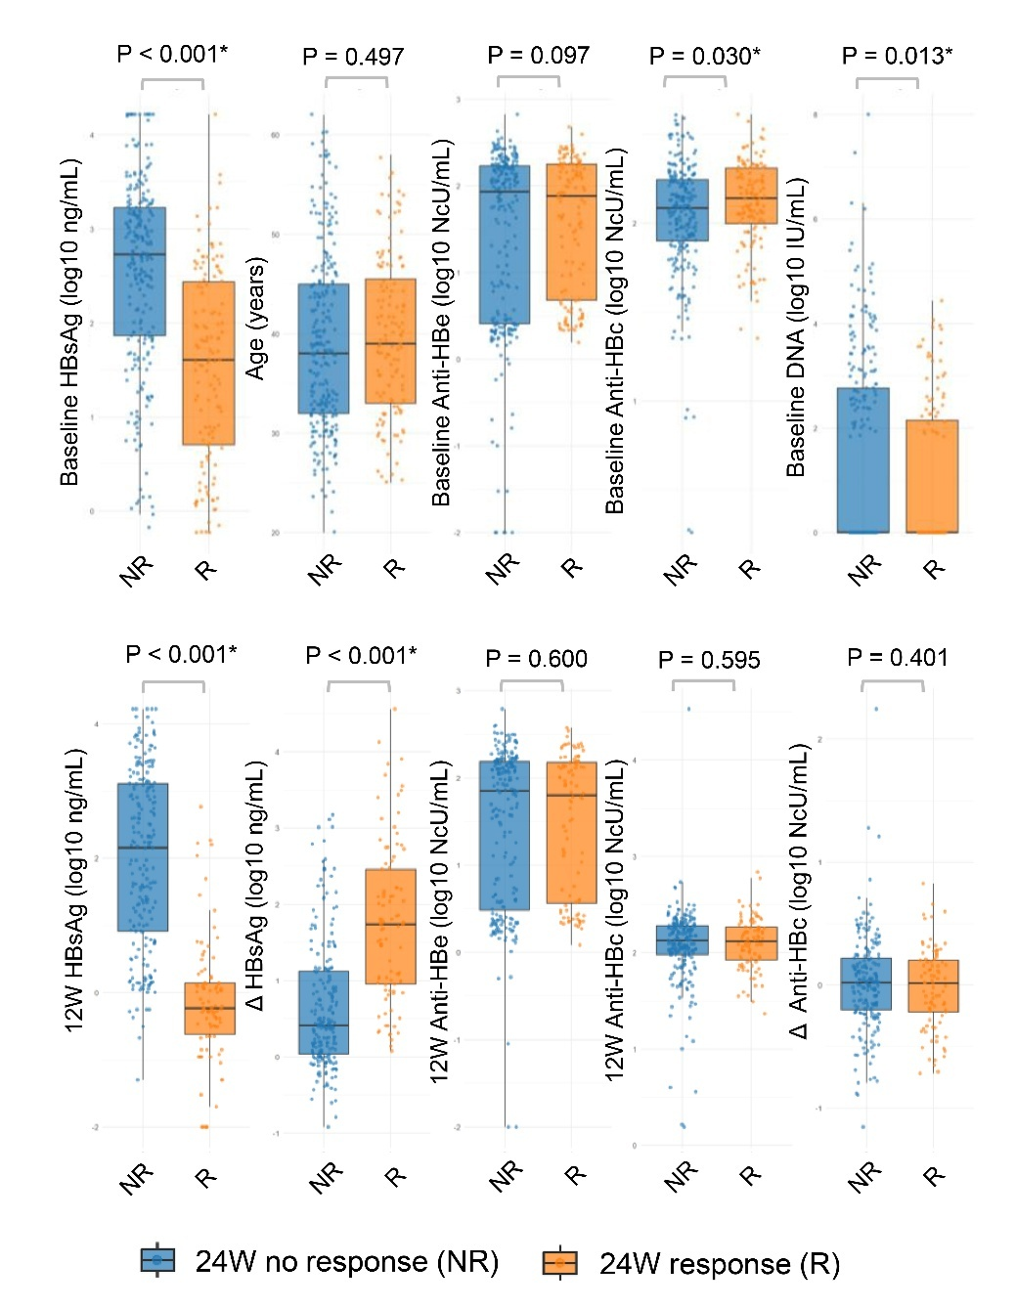
Supplementary Figure 2: Scatter plots stratified by 24-week treatment response.

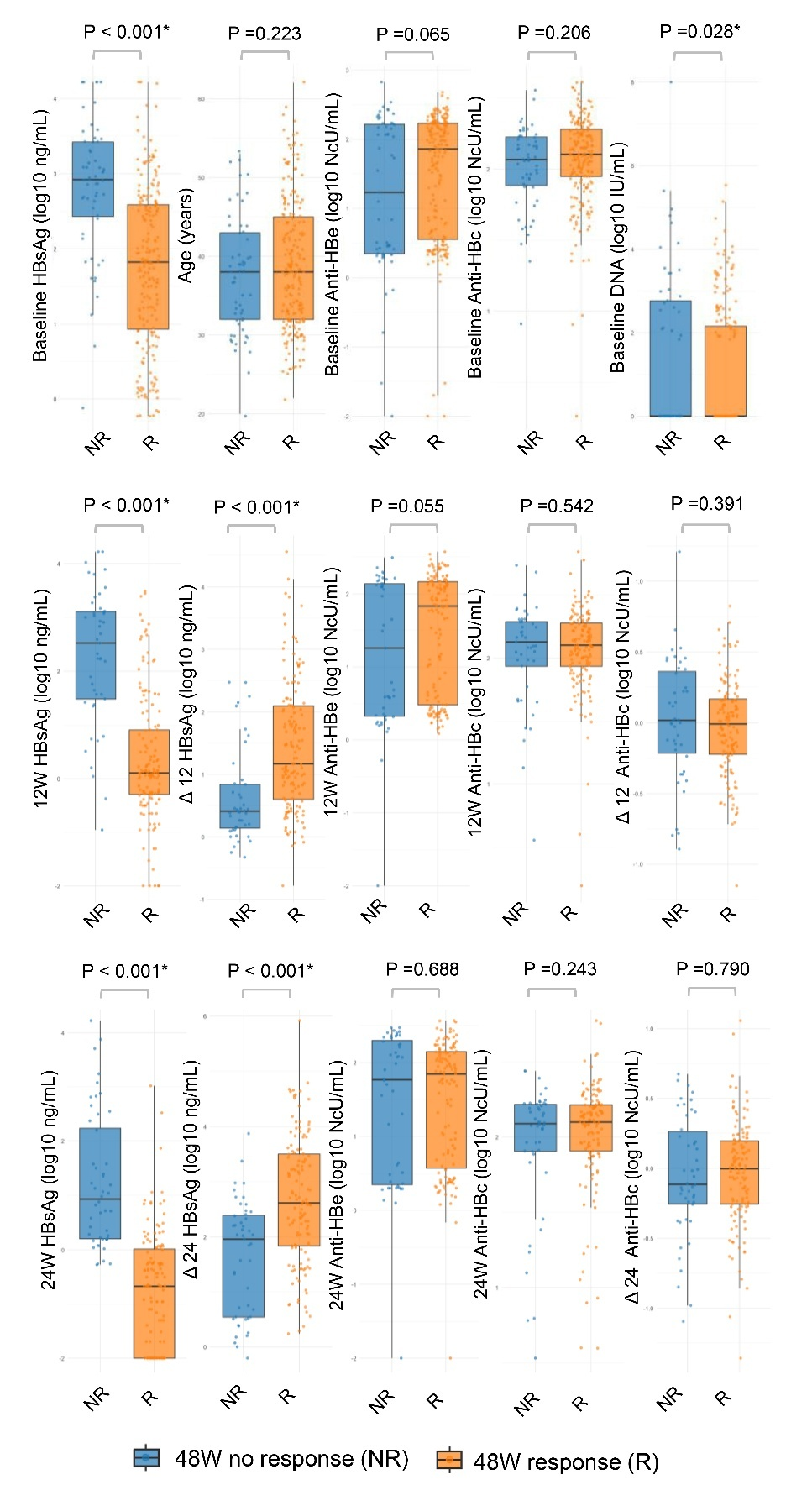
Supplementary Figure 3: Scatter plots stratified by 48-week treatment response.

