Supplementary Information IV

The osteology, taxonomy, and phylogenetic affinities of the Early Jurassic plesiosaur Lusonectes sauvagei

Sven Sachs and Daniel Madzia
Figure S1. Parsimony analysis using equal weights, utilizing the ‘conservative’ operational taxonomic unit of Lusonectes sauvagei. Strict consensus tree. Numbers on nodes show Bremer support values.
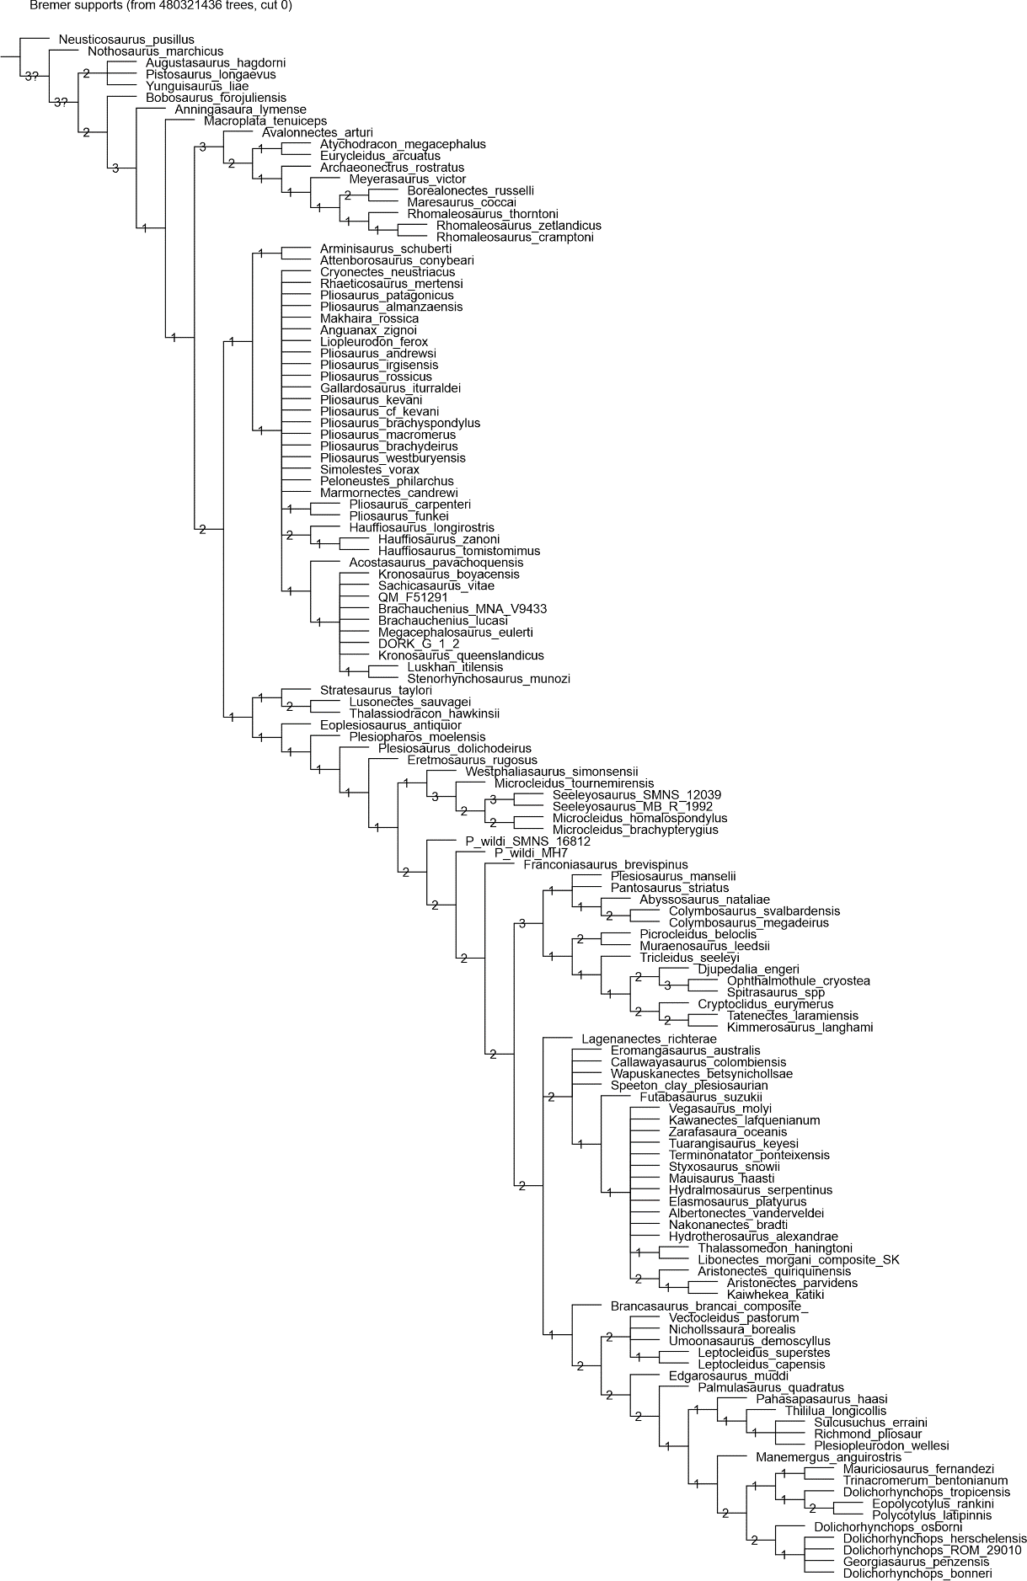

Figure S2. Parsimony analysis with implied weighting (K = 9), utilizing the ‘conservative’ operational taxonomic unit of Lusonectes sauvagei. Strict consensus tree.
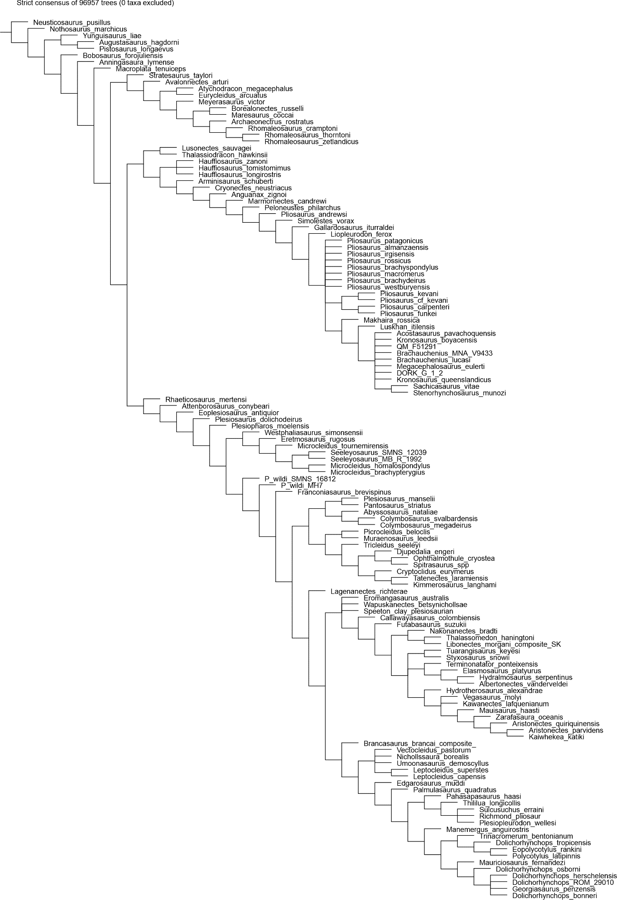

Figure S3. Parsimony analysis with implied weighting (K = 9), utilizing the ‘conservative’ operational taxonomic unit of Lusonectes sauvagei. Symmetric Resampling.
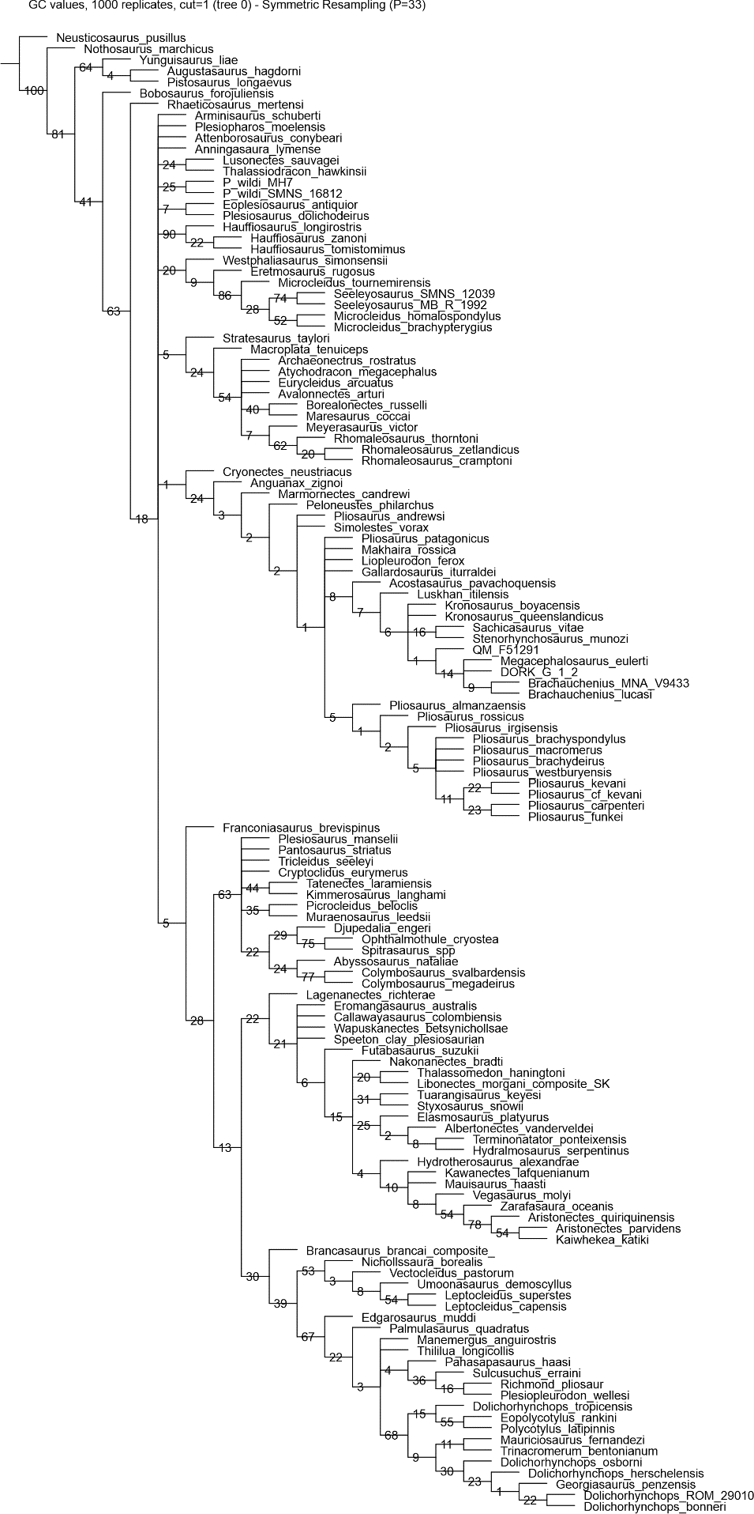

Figure S4. Parsimony analysis with implied weighting (K = 15), utilizing the ‘conservative’ operational taxonomic unit of Lusonectes sauvagei. Strict consensus tree.
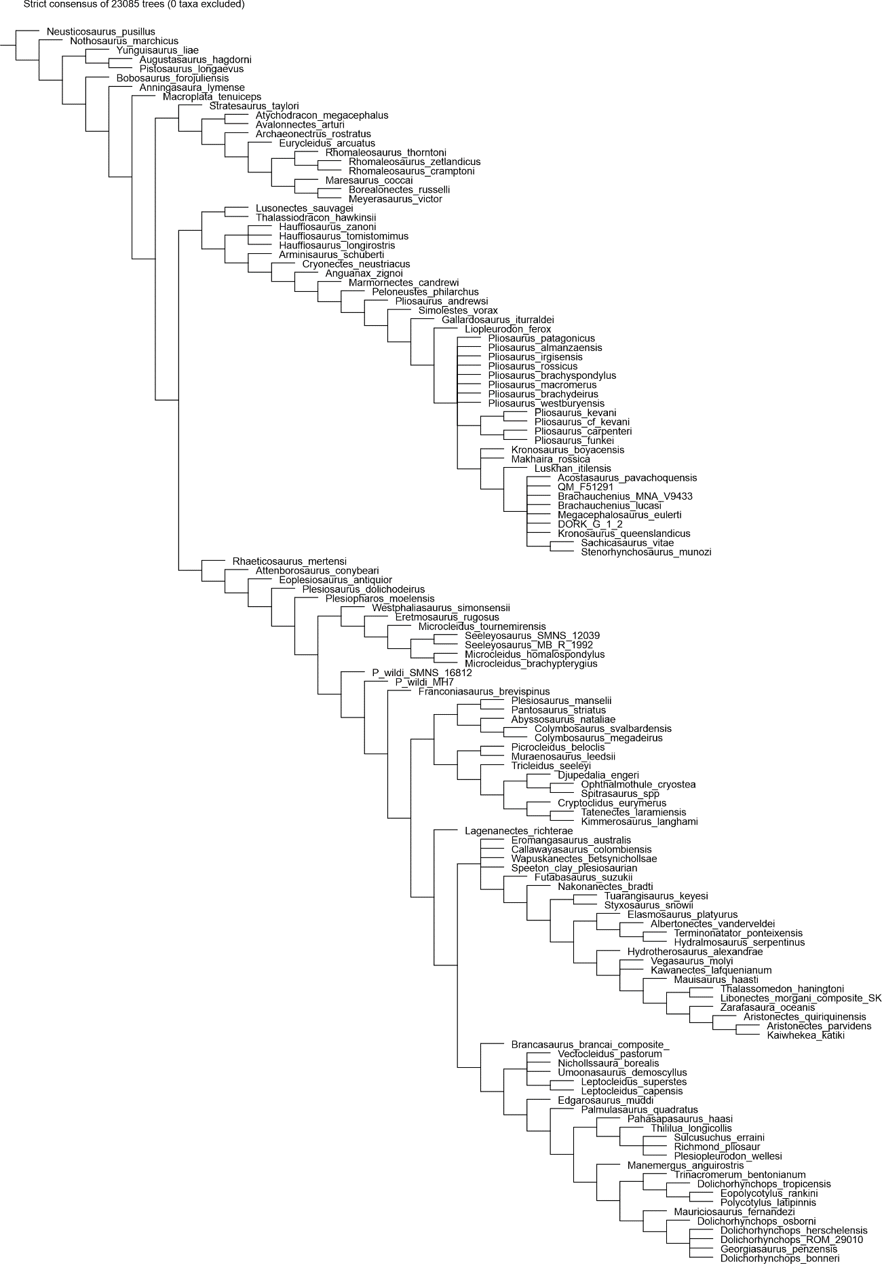

Figure S5. Parsimony analysis with implied weighting (K = 15), utilizing the ‘conservative’ operational taxonomic unit of Lusonectes sauvagei. Symmetric Resampling.
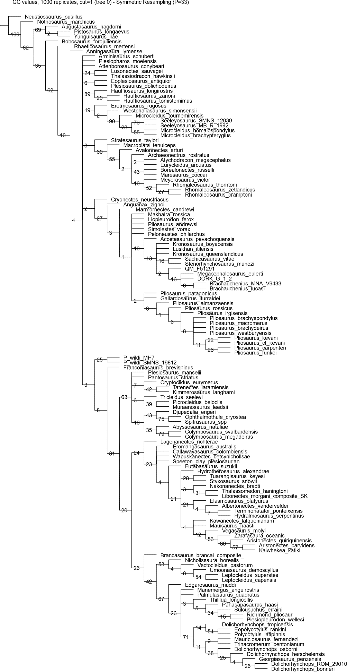
Figure S6. Parsimony analysis using equal weights, utilizing the ‘experimental’ operational taxonomic unit of Lusonectes sauvagei. Strict consensus tree. Numbers on nodes show Bremer support values.
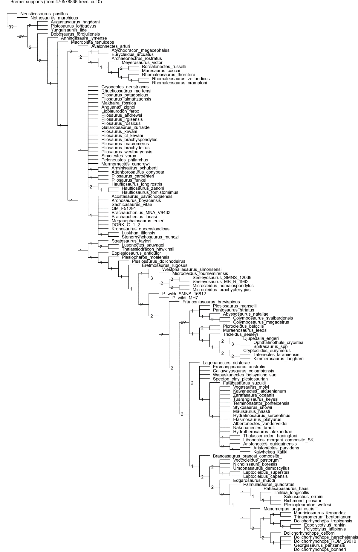

Figure S7. Parsimony analysis with implied weighting (K = 9), utilizing the ‘experimental’ operational taxonomic unit of Lusonectes sauvagei. Strict consensus tree.
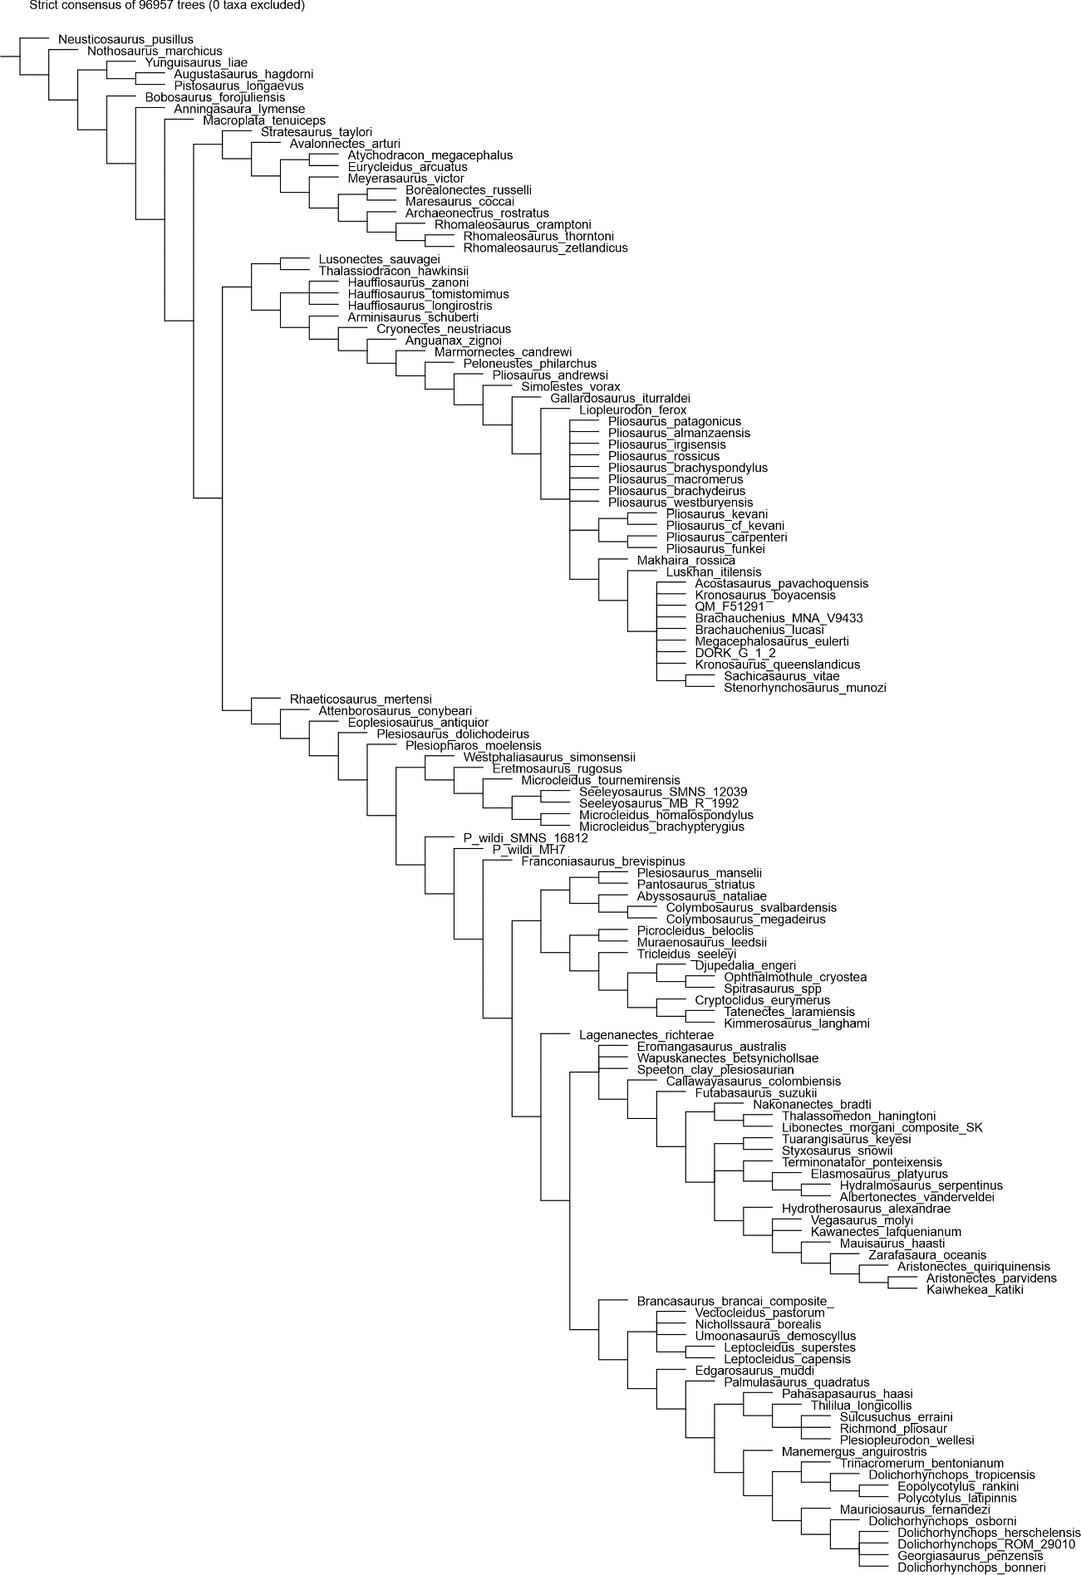

Figure S8. Parsimony analysis with implied weighting (K = 9), utilizing the ‘experimental’ operational taxonomic unit of Lusonectes sauvagei. Symmetric Resampling.
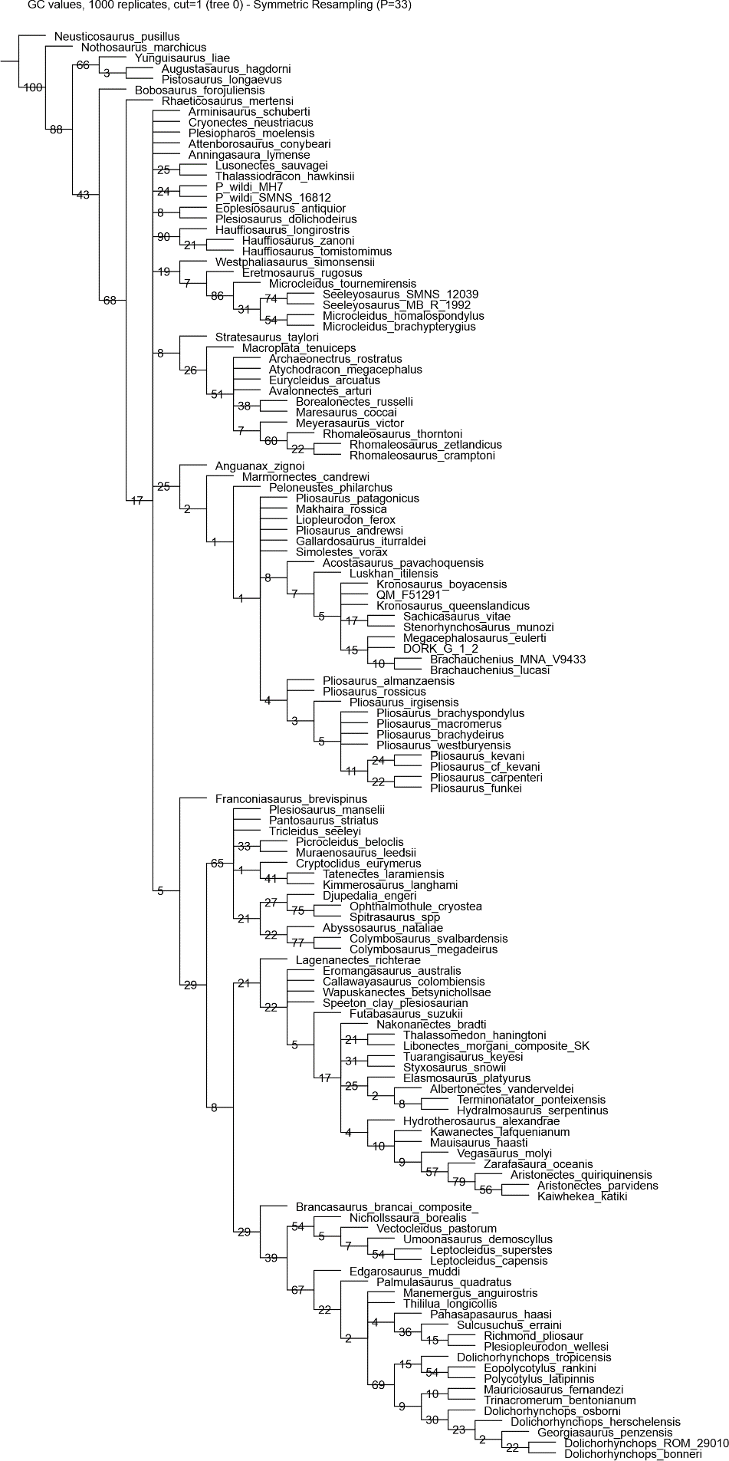

Figure S9. Parsimony analysis with implied weighting (K = 15), utilizing the ‘experimental’ operational taxonomic unit of Lusonectes sauvagei. Strict consensus tree.
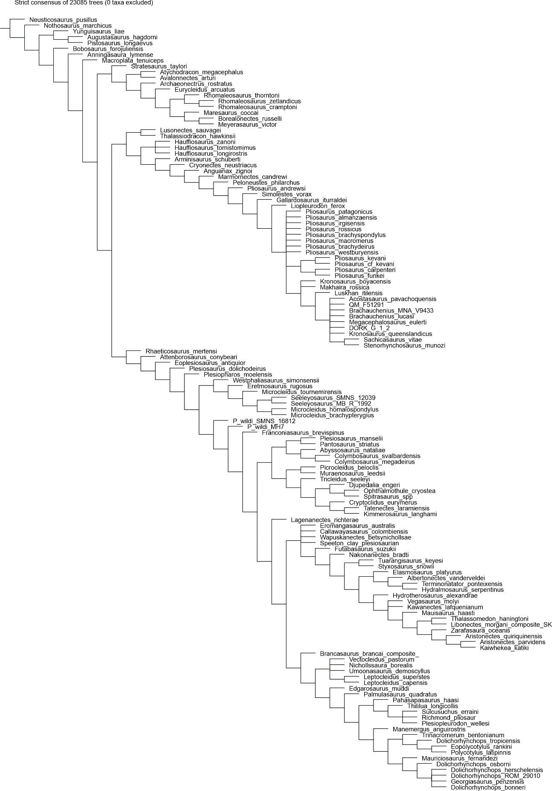

Figure S10. Parsimony analysis with implied weighting (K = 15), utilizing the ‘experimental’ operational taxonomic unit of Lusonectes sauvagei. Symmetric Resampling.
