Earophila badiata species group revision: Supplementary information S3
Quantitative Image Analysis Supplement

Image Setup

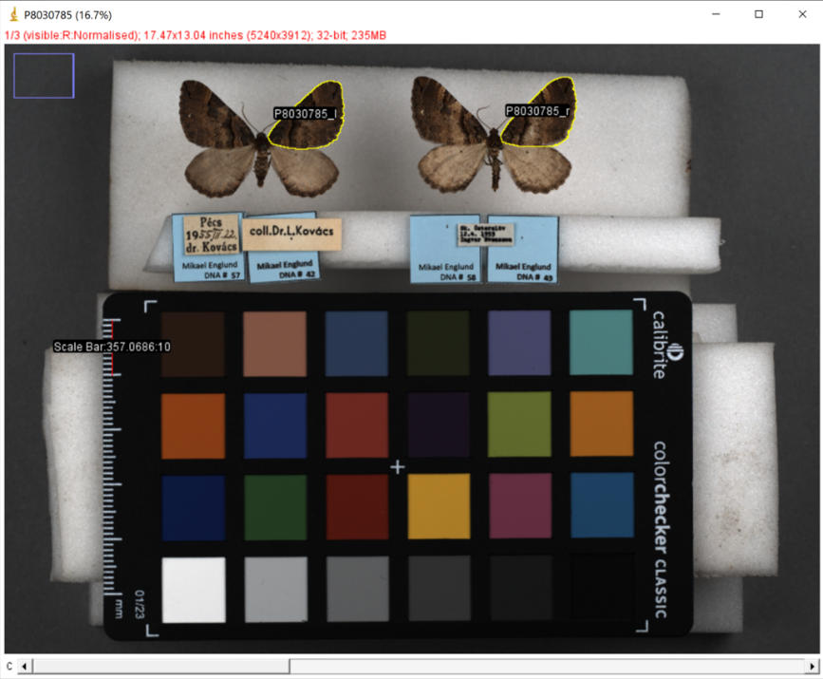
Figure S3.1. Example image setup. Two moths are arranged with their photo label on the left and right, along with a luminance standard. The right wing for each moth is labelled with a region of interest (ROI). The ROIs, shown in yellow, are labelled using the photo number and whether the moth is on the left (l) or the right (r). The scalebar shown in red is marked for 10mm. It denotes the number of pixels, in this case 357, per mm.

Masking Method

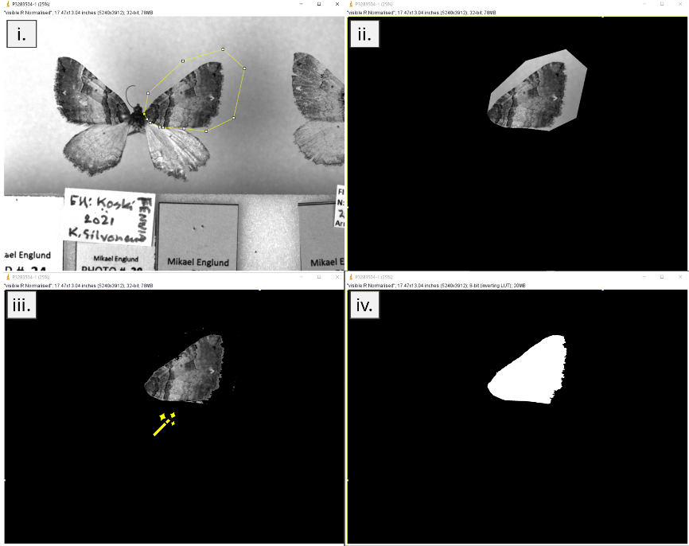

Figure S3.2. Example wing masking. i) A loose polygon is drawn around the wing. ii) The area surrounding the polygon is masked out in black. iii) The remainder of the background is masked using the wand tool. iv) The wing is converted to a white selection and any gaps are filled in white.

Gabor Filtering

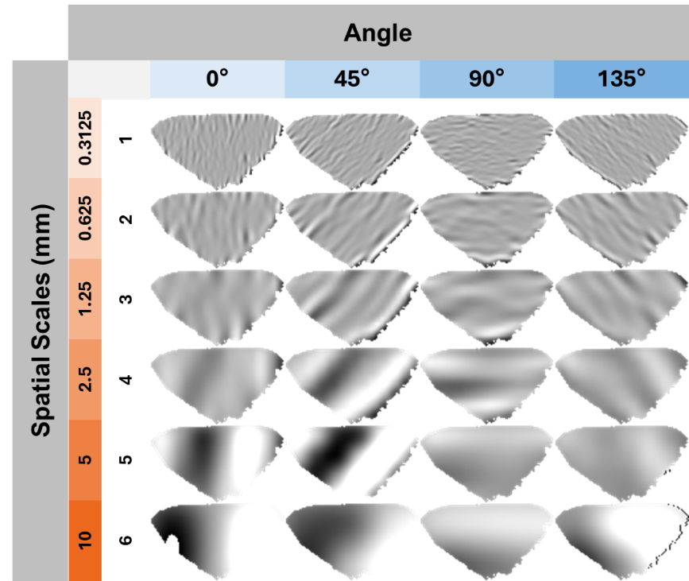

Figure S3.3. Example Gabor filtering of the moth wing for the luminance channel. The x-axis shows the orientation of the Gabor filter in degrees, and the y-axis shows the spatial scale in mm and the associated number code for that scale (1-6). Larger spatial scales correspond with larger patterning. Images show the contrast at that given scale.

Principal Component Analysis

Table S3.1. Contributions to principal components (PC), PC1, PC2, and PC3 shown in ranked absolute order for variables that contributed greater than or equal to 0.10. NB for PC1 and PC2 the values shown have been flipped (multiplied by -1) as the majority were negative.

Variable | PC1 | Variable | PC2 | Variable | PC3
Sat_contrastAvg_2 | 0.125992 | Lum_StdDev | 0.172167 | Lum_contrast_6_135 | 0.172347
Y_contrastAvg_2 | 0.125414 | Lum_Mean | 0.16637 | Lum_SumEnergy | 0.16873
Sat_contrastAvg_3 | 0.123298 | Lum_contrastAvg_1 | 0.164732 | Lum_contrastAvg_6 | 0.168691
Y_contrastAvg_3 | 0.122069 | Lum_contrast_2_45 | 0.161346 | Lum_MaxPower | 0.166406
Sat_contrastAvg_4 | 0.120101 | Lum_contrast_1_0 | 0.158437 | Sat_contrast_6_135 | 0.161151
Y_contrastAvg_4 | 0.119426 | Lum_contrast_3_0 | 0.157817 | Lum_MaxFreq | 0.156466
Sat_contrast_4_45 | 0.11697 | Lum_contrastAvg_2 | 0.157292 | Y_contrast_6_135 | 0.154954
Sat_contrast_1_90 | 0.116805 | Lum_contrast_2_0 | 0.156094 | Sat_MaxFreq | 0.14951
Sat_contrastAvg_1 | 0.116417 | Lum_contrast_1_135 | 0.155317 | X_contrast_6_45 | 0.148898
Y_contrastAvg_5 | 0.116074 | Lum_contrast_1_45 | 0.151001 | Sat_contrastAvg_6 | 0.148774
Sat_contrast_2_90 | 0.115881 | Lum_contrastAvg_3 | 0.150114 | Sat_SumEnergy | 0.148739
Y_contrast_4_45 | 0.115856 | Lum_contrastAvg_4 | 0.149814 | Y_SumEnergy | 0.143592
Y_contrastAvg_1 | 0.115786 | Lum_contrast_4_135 | 0.143267 | Y_contrastAvg_6 | 0.143572
Sat_contrast_1_135 | 0.115482 | Lum_contrast_2_135 | 0.142806 | X_MaxPower | 0.140044
Sat_StdDev | 0.11521 | Lum_contrast_3_45 | 0.141148 | X_SumEnergy | 0.138821
Sat_contrastAvg_5 | 0.114433 | Lum_contrast_1_90 | 0.140256 | X_contrastAvg_6 | 0.138729
Y_contrast_2_90 | 0.114256 | Lum_contrast_4_90 | 0.136207 | Sat_MaxPower | 0.137705
Y_contrast_1_135 | 0.11391 | X_Mean | -0.13614 | Lum_contrast_6_0 | 0.137474
Y_contrast_1_90 | 0.112942 | Lum_contrast_4_0 | 0.135978 | Y_directionality_1 | -0.13343
Y_contrast_5_45 | 0.112785 | Lum_contrastAvg_5 | 0.134699 | Y_MaxPower | 0.132583
Y_StdDev | 0.112359 | Lum_contrast_3_135 | 0.132435 | Sat_directionality_1 | -0.13121
Y_contrast_3_45 | 0.111697 | Sat_Mean | -0.12588 | Y_MaxFreq | 0.126598
Sat_contrast_5_45 | 0.111591 | Major_mm | -0.12483 | Lum_contrast_6_45 | 0.125917
Sat_contrast_3_45 | 0.111474 | Minor_mm | -0.12278 | Y_contrast_6_90 | 0.122825
X_contrast_1_90 | 0.11085 | Y_Mean | 0.122679 | X_MaxFreq | 0.121197
Sat_contrast_3_90 | 0.109762 | Lum_contrast_4_45 | 0.120194 | Sat_contrast_6_90 | 0.116823
Y_contrast_2_0 | 0.109004 | Lum_contrast_2_90 | 0.112477 | Y_verticality_1 | 0.116427
X_contrastAvg_2 | 0.108696 | Lum_contrast_3_90 | 0.110532 | Lum_contrast_6_90 | 0.115656
Y_contrast_3_90 | 0.107632 | Lum_contrast_5_90 | 0.10894 | Y_directionality_2 | -0.11298
Sat_contrast_2_0 | 0.107422 | Lum_contrast_5_135 | 0.105875 | Sat_verticality_1 | 0.112913
X_contrastAvg_4 | 0.107292 |  |  | Sat_directionality_2 | -0.11058
Y_contrast_4_0 | 0.10694 |  |  | Sat_contrast_6_45 | 0.10354
Sat_contrast_4_0 | 0.106795 |  |  | X_verticality_1 | 0.103069
Sat_contrast_3_135 | 0.104417 |  |  | Y_contrast_6_45 | 0.102039
X_contrastAvg_3 | 0.103462 |  |  | Sat_contrast_6_0 | 0.101823
Y_contrast_4_90 | 0.103192 |  |  | X_contrast_6_0 | 0.100715
Y_contrast_3_135 | 0.10309 |  |  | Y_verticality_2 | 0.100701
Sat_contrast_3_0 | 0.103043
X_contrastAvg_1 | 0.102545
Y_contrast_3_0 | 0.10217
Sat_contrast_4_90 | 0.101714
Sat_contrast_2_135 | 0.100508
X_contrast_2_90 | 0.10003

Principal Component Plots

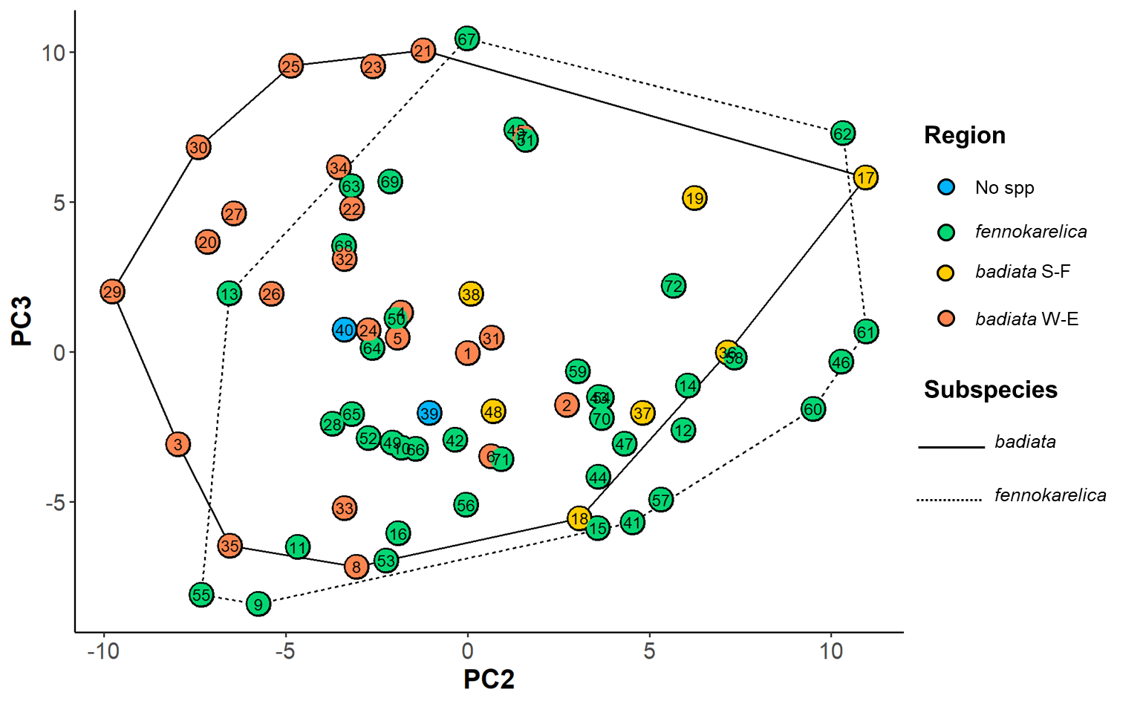
Figure S3.4. Forewing colouration PCA mapping for subspecies. The coloured circles represent the 72 specimens in the wing morphology dataset plotted on a plane with PC2 being the horizontal axis and PC3 the vertical axis. The colour of the circle indicates the regional origin of each specimen and the number inside the circle is the identification number for each specimen. For the full data of the specimens, see Table S2.

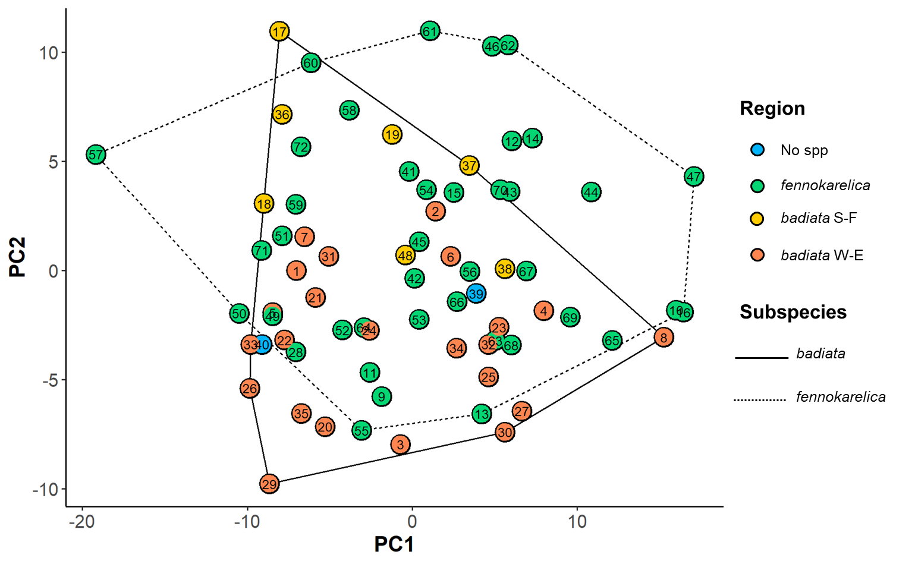
Figure S3.5. Forewing colouration PCA mapping for subspecies. The coloured circles represent the 72 specimens in the wing morphology dataset plotted on a plane with PC1 being the horizontal axis and PC2 the vertical axis. The colour of the circle indicates the regional origin of each specimen and the number inside the circle is the identification number for each specimen. For the full data of the specimens, see Table S2.

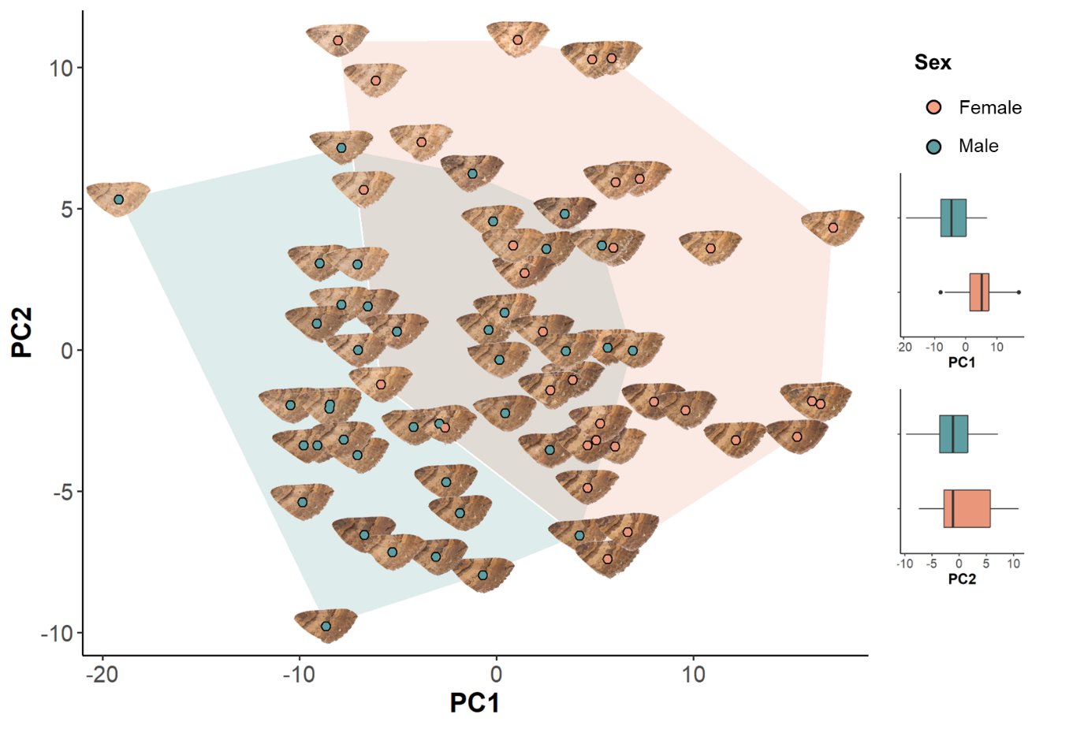
Figure S3.6. Forewing colouration PCA mapping for sex. The coloured circles and wing images represent the 72 specimens in the wing morphology dataset plotted on a plane with PC1 being the horizontal axis and PC2 the vertical axis. The colour of the circles and boxplots indicates the sex of each specimen. The right-hand boxplots show individual comparisons for PC1 and PC2 between sexes.

