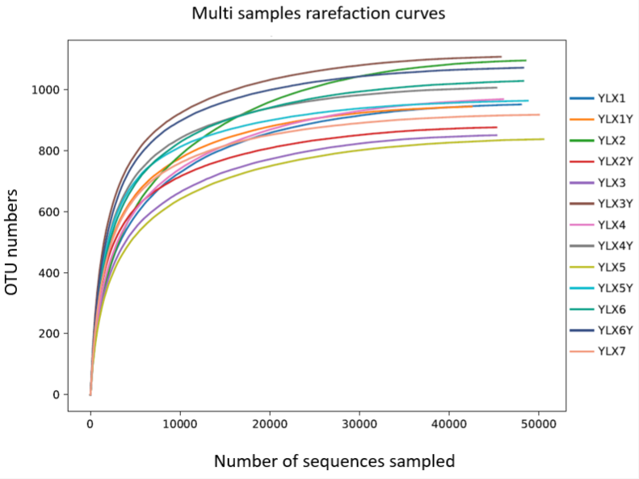
Figure S1. Rarefaction curve of 16S rRNA gene sequencing of the rhizosphere and bulk soils. YLX: pear rhizosphere soil; YLXY: bulk soil.

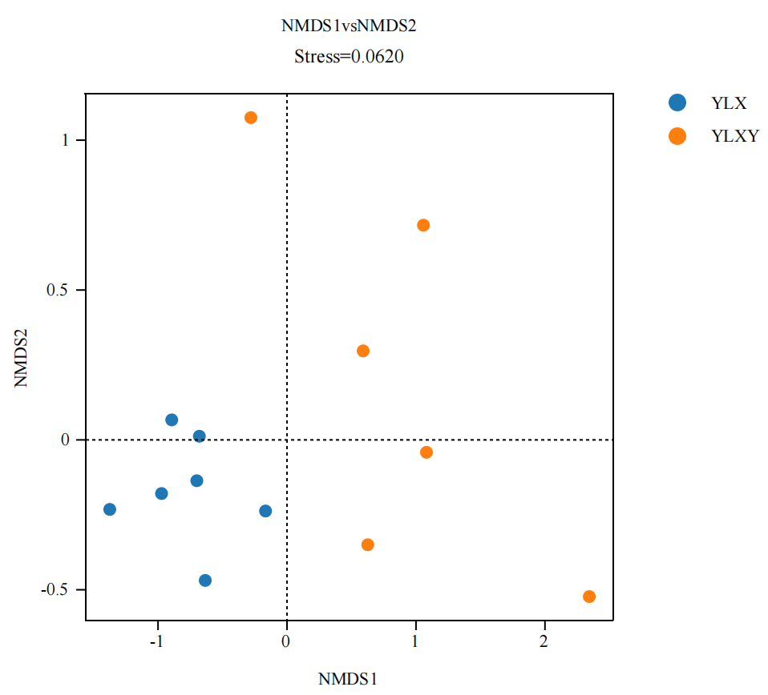
Figure S2. The NMDS analysis between different groups by Bray-Curtis method. YLX: pear rhizosphere soil; YLXY: bulk soil.

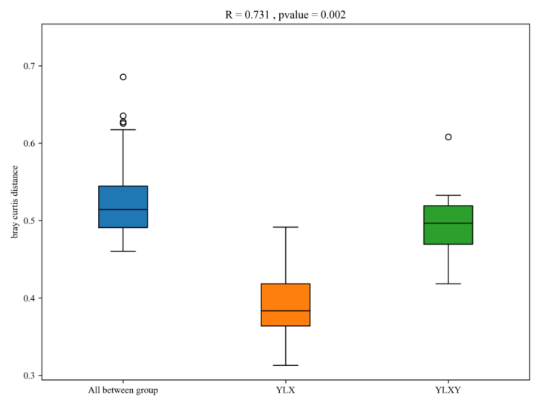
Figure S3. The ANOSIM-based effective OTUs between different groups by Bray-Curtis method. YLX: pear rhizosphere soil; YLXY: bulk soil.

Figure S4. The relative abundances of family with phenotypes related to a) biofilm formation, b) stress tolerance, c) potential pathogenicity and d) mobile elements. YLX: pear rhizosphere soil; YLXY: bulk soil.

