PeerJ Photo/Video Permission Letter
- REQUIRED Title of PeerJ submission: Development of a tongue ultrasound-based predictive model for hypoxemia during painless gastroscopy in ASA I-II patients

- REQUIRED Printed name of copyright holder (must include the name of an individual and their title when signing on behalf of a company/institution. Company/institution names alone are not acceptable): Chen Gao (高晨)
- REQUIRED For figures: Paste the approved images(s) including the figure number(s) as they appear in the PeerJ submission below
For videos: Please supply a brief description of the video(s) including the title, description of content, length of video
Use additional pages as necessary for multiple figures / videos

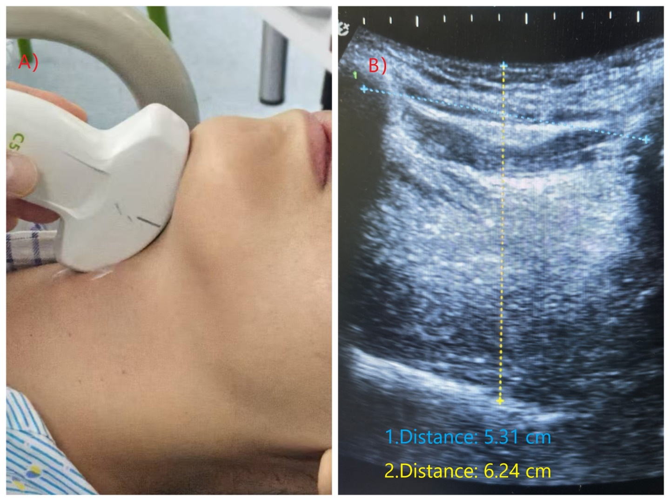
Figure 1

I give my permission to PeerJ to publish the work, as appears above, under the CC-BY 4.0 license (https://peerj.com/about/policies-and-procedures/#open-access-copyright-policy).

REQUIRED Signature of copyright holder 

