MIQE Checklist
1. Plant materials and treatment methods
Annual tea cuttings of Camellia sinensis were cultivated in the Tea Garden of Xinyang Normal University (32.13°N, 114.04°E). Healthy, pathogen-free tea seedlings with uniform growth were selected and subjected to diverse stresses:
① Programmed temperature acclimation (CK: 25/20°C (day/night) for 6 h, CA: cold 10/4°C for 6 h followed by 7-day adaptation, DA: 25/20°C for 7 days);
② Drought (20%W/V PEG6000), collected at 0h, 24h, 48h, and 72 h;
③ Salt (200 mM NaCl), sampled at 0h, 24h, 48h, and 72 h;
④ MeJA (1 mM MeJA, freshly prepared), sampled at 0h, 6h, 12h, and 24h;
⑤ Indole-3-acetic acid (100 µM IAA, freshly prepared) sampled at 0h, 3h, 6h, and 12h.
Each sample consists of tender leaves of C. sinensis collected from four plants.
All fresh plant samples were all flash-frozen in liquid N₂ and stored at -80°C for further assays.
2. Nucleic acid extraction and Reverse transcription
2.1 Nucleic acid extraction
Grind frozen tender leaves into a flour-like powder in liquid N₂ and weight 100 mg for RNA extraction.
Total RNA was isolated using RNAprep Pure Plant Plus Kit (Polysaccharides&Polyphenolics-rich) (catalog No. DP441, TIANGEN Biotech, Beijing, China) according to the manufacturer's instructions. RNase was not available in the operating environment, reagents and consumables. RNA integrity was verified by 1.0% agarose gel electrophoresis and RNA purity and concentration were measured using a Nanodrop 2000 spectrophotometer (Thermo Fisher Scientific, USA).
2.2 Reverse transcription
First strand cDNA from 1 μg of total RNA was carried out by the use of HiScript II 1st Strand cDNA Synthesis Kit (+gDNA wiper) (catalog No. R212, Vazyme Biotech Co.,Ltd, Nanjing, China) according to the manufacturer's protocol.
Briefly,
① Wipe genomic DNA at 42°C for 2 min;
1 × RT master mix (per 20-µL reaction)
Component | Volume/Reaction (µL)
RNase-free dH2O | To 16 µL
4 × gDNA wiper Mix | 4 µL
Oligo (dT) 23VN (50 μM) | 1 µL
Total RNA | 1 µg
② Synthesize the first strand cDNA as follows.
1 × RT master mix (per 20-µL reaction)
Component | Volume/Reaction (µL)
Reaction system ① | 16 µL
10 × RT Mix | 2 µL
HiScript II Enzyme Mix | 2 µL
Total per Reaction | 20.0
Thermocycling conditions for RT reaction
 | Step 1 | Step 2 | Step 3
Temperature | 50°C | 85°C | 4°C
Time | 15 min | 2 min | ∞
RT product was diluted 1:2 or 1:10 or 1:15 by ddH₂O for qPCR analysis.
3. qPCR target information and qPCR oligonucleotides
Specific primers for the CsSAUR genes were designed using Primer-BLAST (https://www.ncbi.nlm.nih.gov/tools/primer-blast/). CsGAPDH and Csβ-actin served as the normalization reference genes. Primers were produced by GENERAL BIOL.
Gene symbol | Locus Name | Forward primer (5'->3') | Reverse primer (5'->3') | Product
Csβ-actin | CSS0008920 | GCCATCTTTGATTGGAATGG | GGTGCCACAACCTTGATCTT | 207
CsGAPDH | CSS0050274 | TTGGCATCGTTGAGGGTCT | CAGTGGGAACACGGAAAGC | 210
CsSAUR7 | CSS0012504 | GTAGGAGGTTCGTAGTTCGCG | GAGTTACAGGACTCGGATCGG | 175
CsSAUR10 | CSS0035781 | GGGCATTTTGCAGTCTACGTG | CAACCCATCTCTCTGCTCGAA | 135
CsSAUR12 | CSS0016597 | GATCCGAATCGAAGACGCCA | AGCTTGATGAAGATCGGGTGG | 190
CsSAUR16 | CSS0047292 | GCTTTAATCTCCACCGTCCTC | ATTGCATGAACAGTGGGTGAT | 153
CsSAUR42  CsSAUR43 | CSS0040677  CSS0043205 | ACGACGACAACAGTGTCACC | AGCCAAACTCTTCTTCGGCA | 159
CsSAUR70  CsSAUR71 | CSS0047497  CSS0015721 | GTCAGCGCAGAGCTCCTAAA | AACTGACTCGTCACCGACAC | 159
CsSAUR73 | CSS0024285 | TTAGCAATCATGGTGGGGCA | TTGGAAGTGGCGAAACTCCT | 174
CsSAUR82 | CSS0036444 | GAGGACGTGAAAGAAGGGCA | GCTGCTAGCTCCAACAACCT | 122
4. qPCR protocol and qPCR validation
qPCR was performed on CFX96 Touch Real-Time PCR Detection System (Bio-Rad, USA) using ChamQ Universal SYBR qPCR Master Mix (catalog No. Q711, Vazyme Biotech Co.,Ltd, Nanjing, China).
qPCR master mix (per 20-µL reaction)
Component | Volume/Reaction (µL) | Final Concentration
Template cDNA | 2 µL | -
Forward primer (10µM) | 0.4 µL | 0.2 µM
Reverse primer (10µM) | 0.4 µL | 0.2 µM
2 × ChamQ Universal SYBR qPCR Master Mix | 10 μL | 1 ×
ddH₂O | 7.2 μL | -
Total | 20 μL | -
Thermocycling conditions for PCR reaction
Step | Temperature | Time
Initial denaturation | 95 ℃ | 30 sec
40 cycles | 95 ℃ | 5 sec
40 cycles | 60 ℃ | 30 sec
The dissolution curve procedure was set as: starting temperature is 65℃; final temperature is 95℃; holding time is 00:05; temperature increment is 0.5℃; the dissolution curves of all primers show single peak, indicating the specificity of the primer (Supplementary Raw Data of qPCR).
5. Calibration curves and PCR efficiency
The PCR amplification efficiency for each primer pair was determined using a standard curve generated from a 5-fold serial dilution of cDNA (1/5, 1/25, 1/125, and 1/625. The slope and correlation coefficient (R²) of each curve obtained Ct values were then used to calculate the PCR efficiency (E) using the formula E = (5^{(−1/slope)} − 1) ×100%.
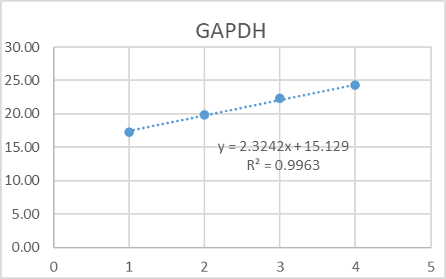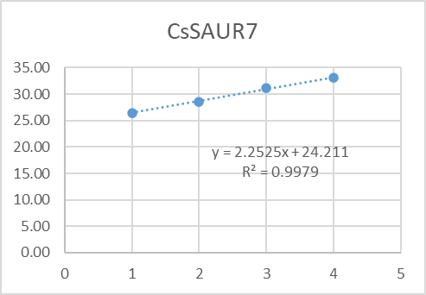
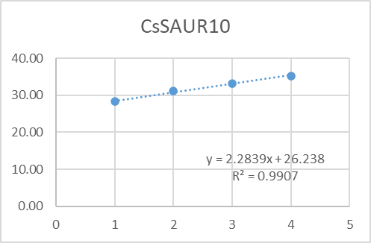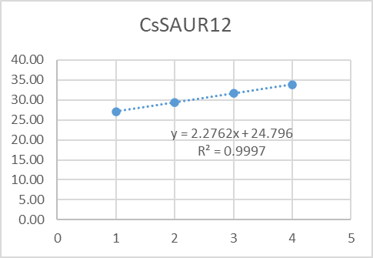
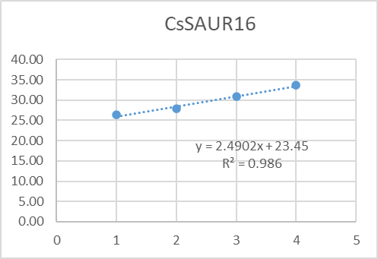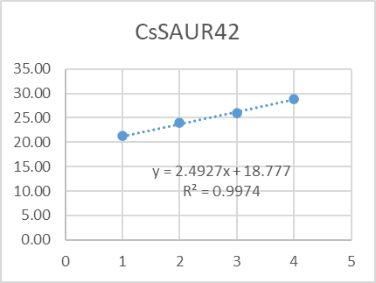
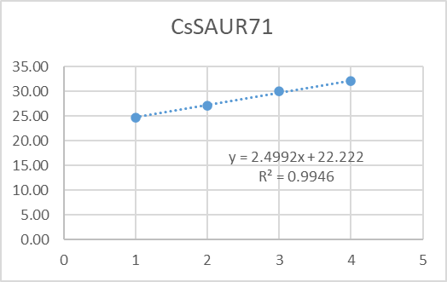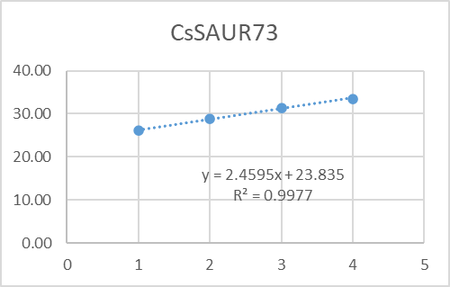
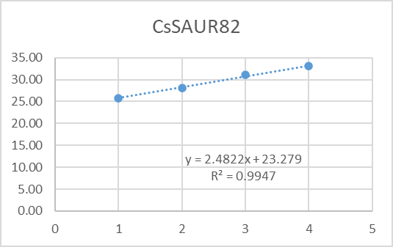

Primer | R² | Slope | E (%)
CsGAPDH | 0.9963 | 2.3242 | 99.86%
CsSAUR7 | 0.9979 | 2.2525 | 104.32%
CsSAUR10 | 0.9907 | 2.2839 | 102.3%
CsSAUR12 | 0.9997 | 2.2762 | 102.8%
CsSAUR16 | 0.986 | 2.4902 | 90.8%
CsSAUR42 | 0.9974 | 2.4927 | 90.73%
CsSAUR71 | 0.9946 | 2.4992 | 90.41%
CsSAUR73 | 0.9977 | 2.4595 | 92.39%
CsSAUR82 | 0.9947 | 2.4822 | 99.47%
6. Primer specifity
6.1 DNA gel electrophoresis (2% agarose gel)
6.2 Melt curve analysis
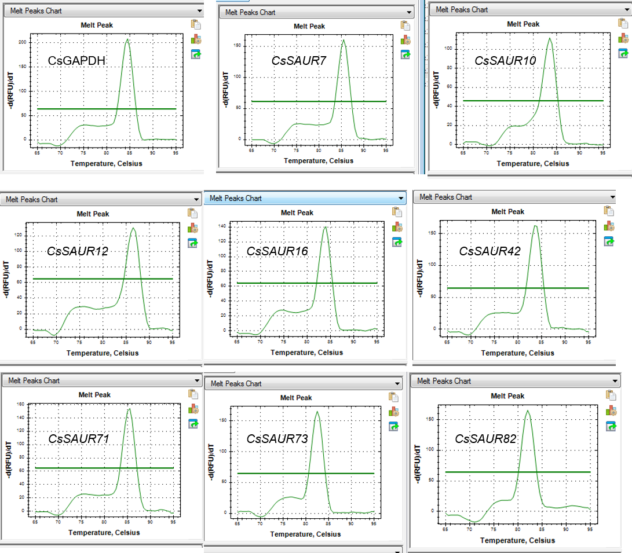
7. Data analysis
The Cq values were determined by the thresholding method, with results for each sample provided in supplementary Table S11. Relative quantification was calculated according to the 2^{-ΔΔCT} method. The mean of CsGAPDH and Csβ-actin expression was used as a housekeeping control. Four experimental replicates were performed for each sample. Statistical differences were determined through one-way ANOVA followed by the Newman-Keuls test for multiple groups comparison, using GraphPad Prism software (10.4.1) (GraphPad Software, Inc., San Diego, CA).

