Serum lncRNA H19/miR-675/PPARα expression before middle gestation and their associations with macrosomia risk in singleton pregnancies without gestational diabetes mellitus: a preliminary study

Qiu-Yan Yu, MD, PhD^{1,*}; Ming-Min Jin, MD¹; Miao-Miao Ding, MD¹; Bin-Wei Cheng, MD¹; Xiao-Xia He, MD, PhD²; Xin-Jun Yang, MD, PhD^{1,*}
¹Department of Epidemiology and Health Statistics, School of Public Health, Wenzhou Medical University, Wenzhou, Zhejiang, China
²Clinical laboratory, The Affiliated Hospital of Inner Mongolia Medical University, Mongolia, China

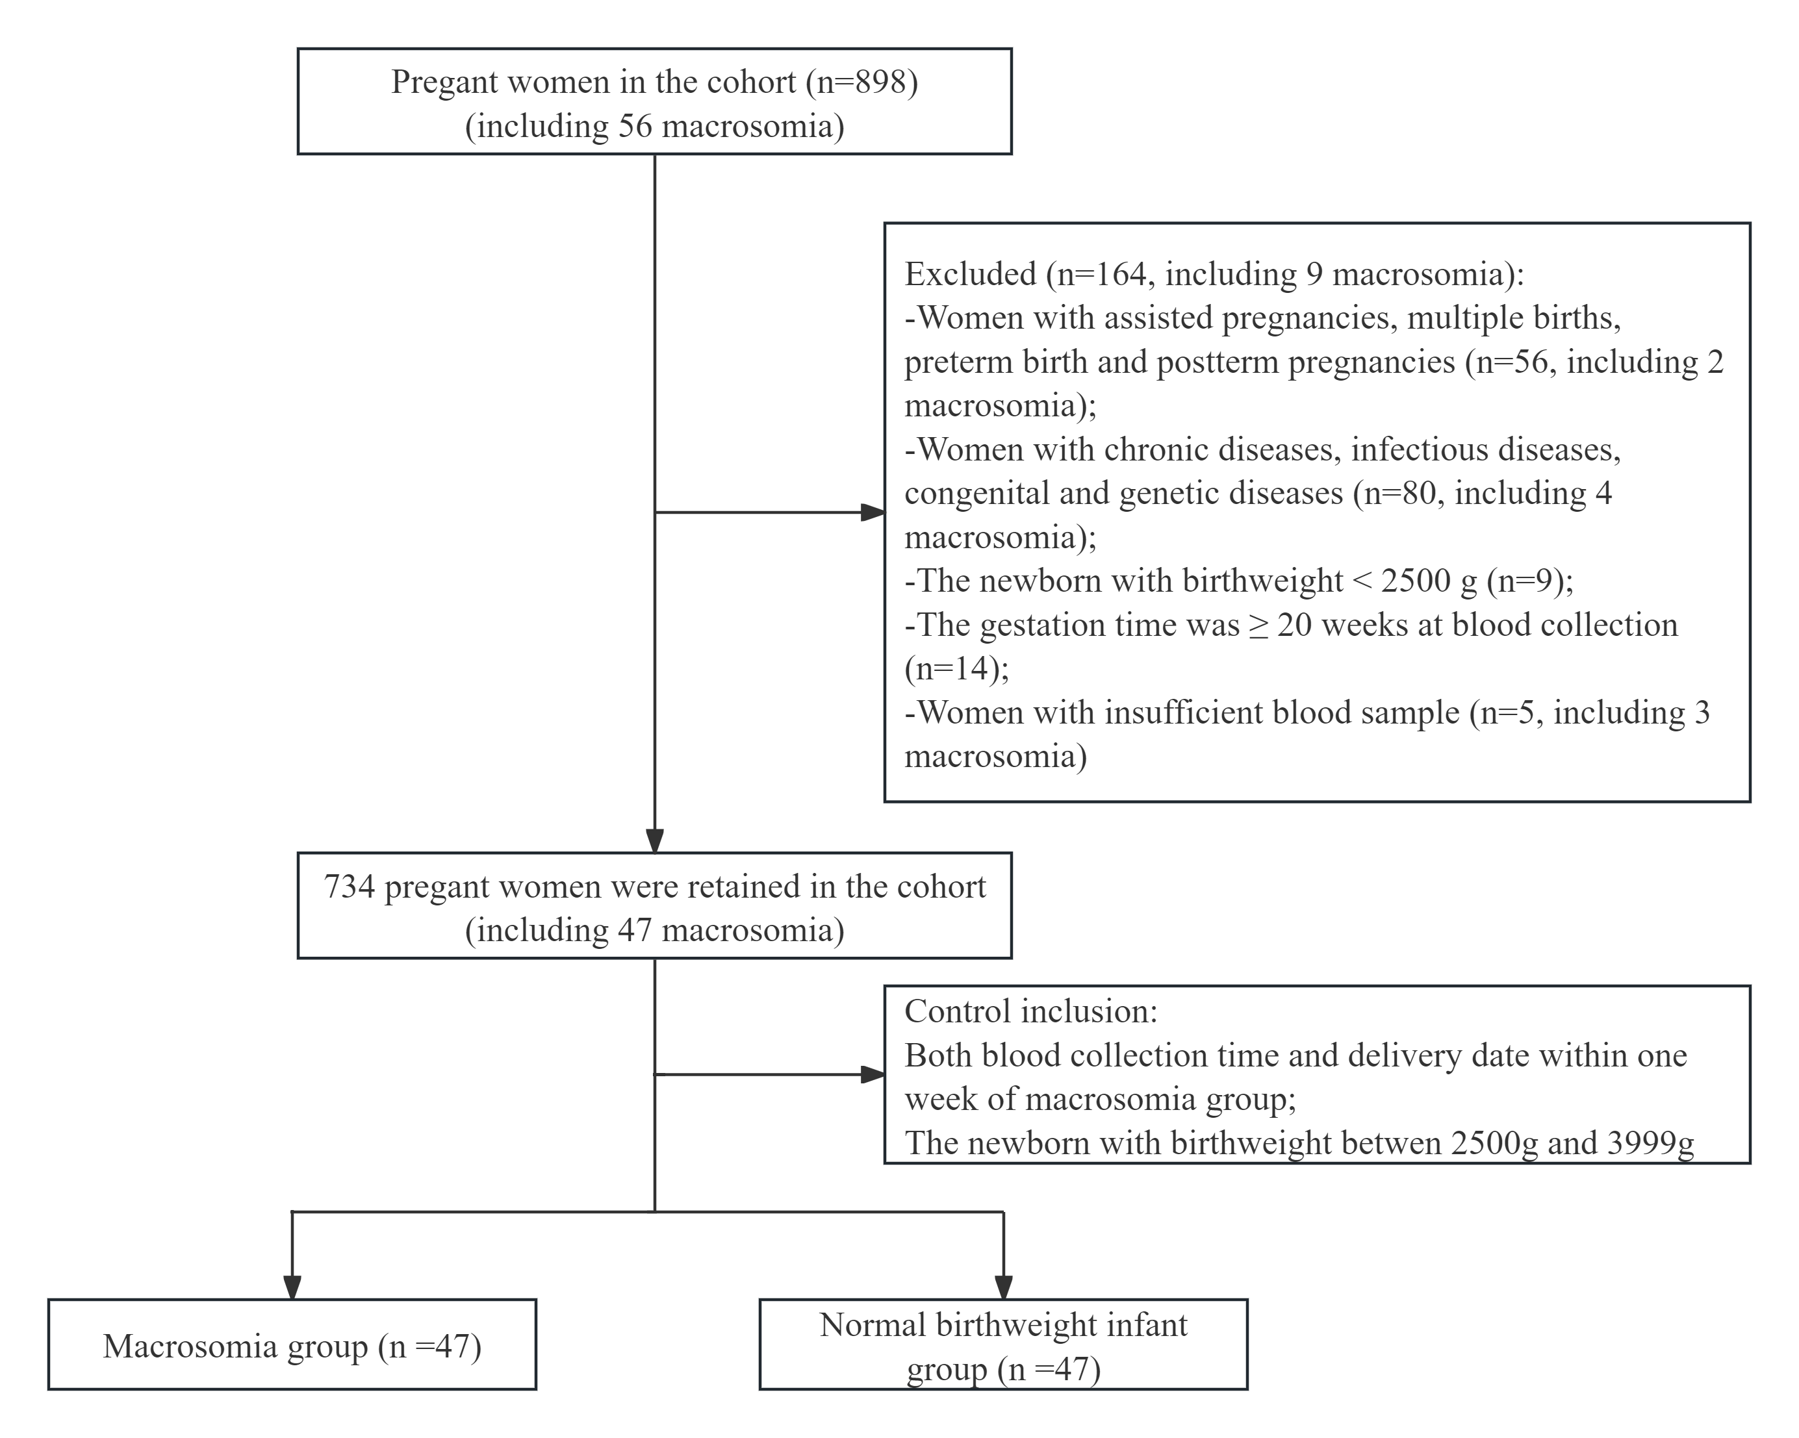
Figure S1 Flow chart of participant screening in the nested case-control study.
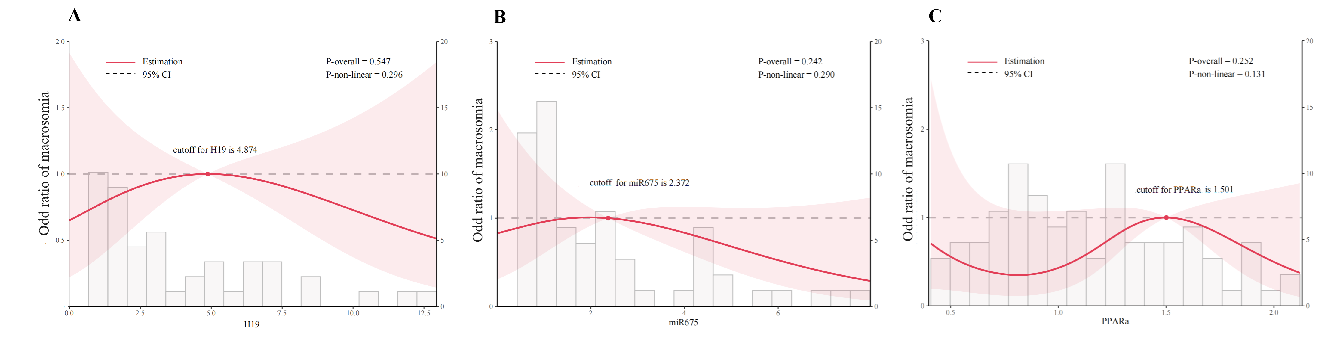
Figure S2 Restricted cubic spline analysis between maternal serum lncRNA H19, miR-675, the protein level of PPARα and the risk of macrosomia.
A : lncRNA H19; B: miR-675; C: the protein level of PPARα. logistic models are conducted without adjustment of any confounding factors. Odds ratios are indicated solid red lines and 95% CIs by shaded areas. The horizontal dotted lines represent the odds ratio of 1 as reference

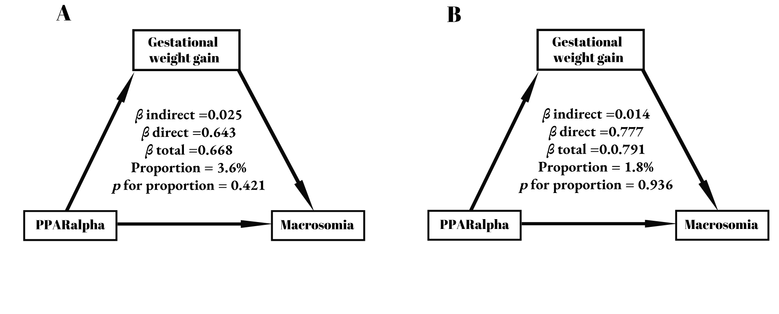
Figure S3 Mediation effect of gestational weight gain between maternal serum PPARα and macrosomia occurrence
- :unadjusted by any confounding factors; (B): adjusted by BMI before pregnancy and gestational weeks using conditional logistic models

Figure S4 The receiver operating characteristic curves of maternal serum H19, miR-675, and PPARα as biomarkers to predict macrosomia

The basic model were constructed with TC, TG, HDL, LDL, maternal age, ethnicity, parity, and BMI before pregnancy
Table S1. Maternal and neonatal baseline characteristics
Characteristics | Pregnant women (n=898)
Maternal age (years) | 28.00 (25.00, 30.00)
Maternal BMI before pregnancy (kg/m²) | 21.23 (19.54, 23.44)
Education, n (%)
≤ High school | 541 (60.24)
> High school | 354 (39.42)
Missing | 3 (0.33)
Drinking before pregnancy, n (%)
No | 693 (77.17)
Yes | 47 (5.23)
Missing | 158 (17.59)
Smoking before pregnancy, n (%)
No | 732 (81.51)
Yes | 14 (1.56)
Missing | 152 (16.93)
Exercise during pregnancy, n (%)
≤ 3 times/week | 408 (45.43)
4-6 times/week | 55(6.12)
≥ 7 times/week | 211(23.50)
Missing | 224 (24.94)
Sleep duration during pregnancy (h) | 8.00 (8.00, 9.50)
Gestational weight gain (kg) | 14.00 (10.58, 17.00)
Blood collection time (weeks) | 11.00 (9.00, 13.00)
Gestational weeks (weeks) | 39.00 (38.00, 40.00)
Parity, n (%)
Primipara | 357 (39.76)
Multipara | 541 (60.24)
Gravidity, n(%)
1 | 261 (29.06)
>1 | 637 (70.94)
Mode of delivery, n (%)
C-section | 339 (37.75)
Vaginal | 557 (62.03)
Missing | 2 (0.22)
Infantsex, n(%)
Male | 512 (57.02)
Female | 386 (42.98)
Infant length (cm) | 50.00 (50.00, 50.00)
Birthweight (g) | 3,329.82 ± 442.01
Low birthweight, n(%) | 24 (2.67)
Macrosomia, n (%) | 56 (6.24)

Table S2. Comparison analysis of data before and after imputation
Characteristics | Data without imputation  (n = 734) | Data with imputation  (n = 734) | P values | SMD
Maternal age (years) | 27.00 (25.00, 30.00) | 27.00 (25.00, 30.00) | 0.998 | <0.001
Han ethnicity | 683 (93.1) | 682 (93.0) | 1.000 | <0.001
Primipara | 290 (39.5) | 289 (39.4) | 1.000 | 0.002
Receiving ≤ 12 years' education | 437 (59.5) | 437 (59.7) | 0.992 | 0.003
BMI before pregnancy (kg/m²) | 21.23 (19.53, 23.41) | 21.23 (19.53, 23.39) | 0.935 | 0.004
Fasting blood glucose (mmol/L) | 4.75 (4.51, 4.95) | 4.75 (4.51, 4.96) | 0.940 | 0.004
Gestational age (weeks) | 39.00 (38.00, 40.00) | 39.00 (38.00, 40.00) | 0.979 | 0.001
Gestational weight gain (kg) | 14.00 (11.00, 17.50) | 14.00 (11.00, 17.20) | 0.914 | 0.007
Vaginal delivery | 475 (64.7) | 475 (64.8) | 1.000 | 0.002
Newborn length (cm) | 50.00 (50.00, 50.00) | 50.00 (50.00, 50.00) | 0.820 | 0.003
< 7000 RMB of family income per month | 391 (53.3) | 299 (52.2) | 0.737 | 0.022
Working during pregnancy | 393 (53.5) | 338 (53.3) | 0.976 | 0.005
Sleep duration during pregnancy | 8.00 (8.00, 9.00) | 8.00 (8.00, 9.00) | 0.744 | 0.016
Drinking before pregnancy | 43 ( 5.9) | 40 ( 5.9) | 1.000 | 0.001
Smoking before pregnancy | 12 ( 1.6) | 12 ( 1.8) | 1.000 | 0.009
< 3 frequencies of physical exercise during pregnancy per week | 443 (60.4) | 363 (59.2) | 0.713 | 0.023
> 7 frequencies of cereals intake per week | 704 (95.9) | 651 (95.7) | 0.973 | 0.009
> 7 frequencies of nuts intake per week | 180 (24.5) | 168 (25.6) | 0.674 | 0.026
> 7 frequencies of meats intake per week | 374 (51.0) | 351 (51.5) | 0.889 | 0.010
> 7 frequencies of seafood intake per week | 202 (27.5) | 192 (28.3) | 0.797 | 0.017
> 7 frequencies of soybean intake per week | 248 (33.8) | 231 (34.0) | 0.971 | 0.005
> 7 frequencies of vegetable intake per week | 569 (77.5) | 525 (76.9) | 0.818 | 0.016
> 1 egg per day | 321 (43.7) | 287 (42.8) | 0.776 | 0.018
> 7 frequencies of fruits intake per week | 601 (81.9) | 549 (81.1) | 0.755 | 0.020
> 7 frequencies of milk and milk products intake per week | 287 (39.1) | 268 (39.5) | 0.930 | 0.008
> 7 frequencies of folic acid intake per week | 693 (94.4) | 580 (94.3) | 1.000 | 0.005
Data are show as n (%), mean (SD), or median (lower quartile, upper quartile).
SD= standard deviance. SMD = standardized mean difference.
Multiple Imputation was performed by random forest
Table S3. Sensitivity analysis on association of the protein level of PPARα in maternal serum with incidence of macrosomia
Variables | No. of macrosomia/total | Model 1 |  | Model 2 |  | Model 3
Variables | No. of macrosomia/total | cOR (95%CI) | P value | aOR (95%CI) | P value | aOR (95%CI) | P value
Among neonate-mother pairs ≤ 40 weeks’ gestation
Per unit decrease |  | 0.58 (0.30, 1.12) | 0.104 | 0.64 (0.30, 1.39) | 0.259 | 0.67 (0.30, 1.48) | 0.326
Tertile 1 | 14/30 | 0.28 (0.07, 1.16) | 0.080 | 0.36 (0.07, 1.96) | 0.240 | 0.37 (0.06, 2.14) | 0.268
Tertile 2 | 12/29 | 0.27 (0.07, 1.03) | 0.056 | 0.21 (0.05, 0.97) | 0.045 | 0.20 (0.04, 0.99) | 0.048
Tertile 3 | 15/27 | Reference |  | Reference |  | Reference
Among neonate-mother pairs without history of macrosomia
Per unit decrease |  | 0.80 (0.37, 1.72) | 0.566 | 0.95 (0.35, 2.60) | 0.927 | 0.78 (0.20, 3.07) | 0.993
Tertile 1 | 12/26 | 0.58 (0.12, 2.90) | 0.511 | 1.62 (0.15, 18.19) | 0.694 | 1.88 (0.13, 27.93) | 0.955
Tertile 2 | 9/27 | 0.37 (0.09, 1.54) | 0.172 | 0.16 (0.02, 1.15) | 0.068 | 0.14 (0.02, 1.14) | 0.066
Tertile 3 | 14/26 | Reference |  | Reference |  | Reference
Among neonate-mother pairs with maternal blood samples collected ≤ 13 weeks’ gestation
Per unit decrease |  | 0.68 (0.34, 1.33) | 0.257 | 0.64 (0.28, 1.45) | 0.286 | 0.64 (0.28,1.45) | 0.285
Tertile 1 | 10/22 | 0.46 (0.12, 1.83) | 0.268 | 0.44 (0.08, 2.45) | 0.351 | 0.44 (0.08, 2.43) | 0.346
Tertile 2 | 10/25 | 0.37 (0.11, 1.29) | 0.118 | 0.27 (0.06, 1.10) | 0.067 | 0.26 (0.06, 1.09) | 0.065
Tertile 3 | 17/27 | Reference |  | Reference |  | Reference
OR (95%CI) was estimated by multivariate conditional logistic regression
Model 2 was conducted with adjusting for pre-pregnancy BMI, maternal age.
Model 3 was conducted with adjusting for pre-pregnancy BMI, maternal age, and neonatal sex.

