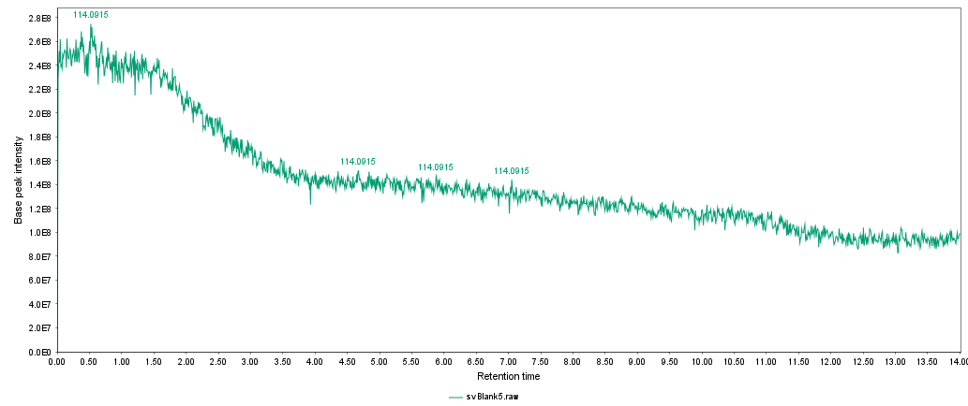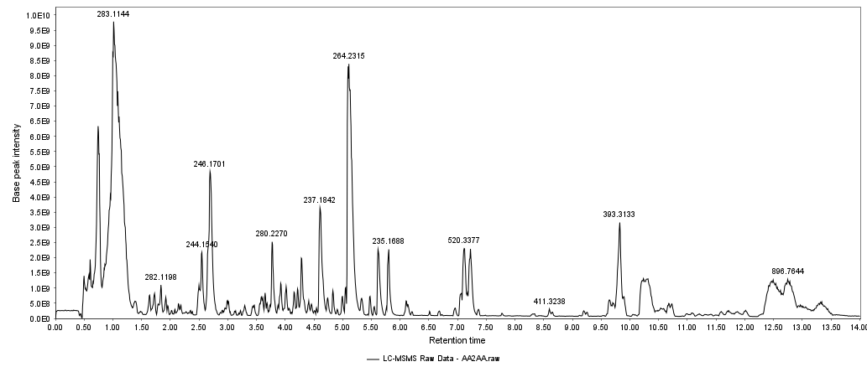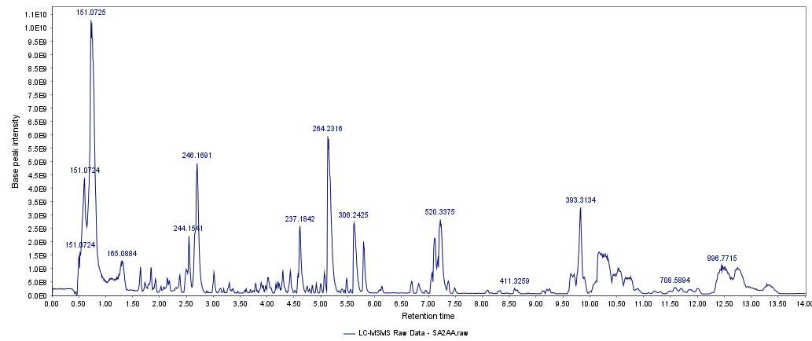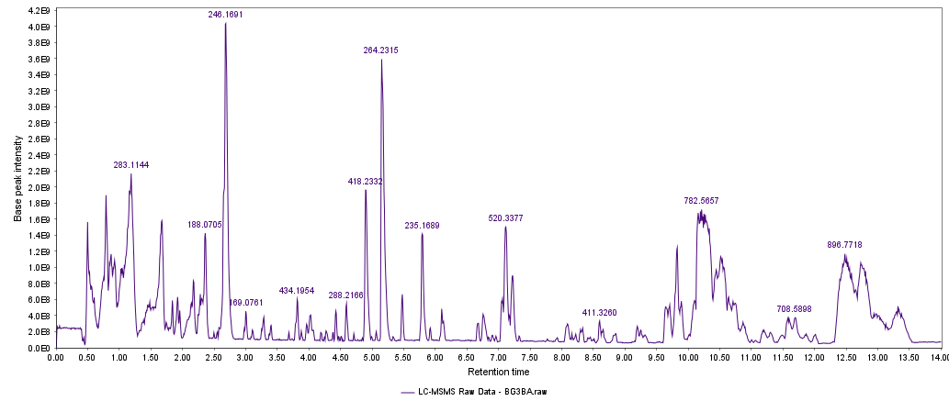
AA2AA
SA2AA
BG3BA
Solvent Blank
Supplementary E: Total ion chromatograms acquired from the LC-MS/MS analysis of solvent blank, AA2AA, SA2AA, and BG3BA

