Supplementary Information
Table S1. The values of the hyperparameters used for our enhanced BPSO ………………… 2

Table S2. Per-class precision, recall, F1-score, and PR-AUC for alpha T5 and O2 EEG classification …………………………………………………………………………….…… 3

Table S3. Results of EEG classification obtained with standard and enhanced BPSO for different channels across classifiers …………………………………………………………. 4

Table S4. Mean accuracy scores and p-values of permutation tests on the best classification cases in Experiment I with each classifier …………………………………………………… 5

Table S5. Results of the Shapiro Wilk test on the normality of the performance differences between classification with enhanced BPSO, standard BPSO, and without feature selection across each classifier and metric score …………………………………………………….... 6

Table S6. The classification results of EEG beta signals with complete and reduced feature set for T6, O1, and OZ channels across classifiers ………………………....…………………… 7

Table S7. Minimum, maximum, mean, and standard deviation of the T5 EEG signal classification results using each classifier over 20 BPSO independent runs ……………….... 8

Table S8. Hyperparameter sensitivity analysis results on alpha T5 EEG classification ……... 9

Table S9. Average execution time of the computation of persistent homology, visibility graph, and BPSO search with T5 and O2 alpha EEG across five repetitions …………………….… 10

Figure S1. Confusion matrices of the EEG classifications …….……………………….…... 11

Figure S2. Feature importance plots for the classification of alpha T5 EEG ……...………. 12

Figure S3. Features selected in T5 EEG signal classification with each classifier over 20 BPSO independent runs ……...……………………………………………………….……. 13
Table S1: The values of the hyperparameters used for our enhanced BPSO.
Parameter | Value
Number of particles | 100
Sub-swarm sizes | 20
Number of iterations | 200
Inertia weight (ω) | Gradually decreasing from 0.9 to 0.1
Acceleration coefficient (c₁) | Gradually decreasing from 2 to 1
Acceleration coefficient (c₂) | Gradually increasing from 1 to 2
Acceleration coefficient (c₃) | Gradually increasing from 1 to 2
Mutation rate | 0.05

Table S2: Per-class precision, recall, F1-score, and PR-AUC for alpha T5 and O2 EEG classification.
Channel | Classifier | Class | Precision | Recall | F1-score | PR-AUC
T5 | LR | 0 | 63.62 | 28.21 | 35.46 | 63.14
T5 | LR | 1 | 72.21 | 94.49 | 81.10 | 74.81
T5 | SVM | 0 | 80.00 | 10.21 | 17.92 | 45.73
T5 | SVM | 1 | 69.04 | 100.0 | 81.09 | 45.73
T5 | RF | 0 | 77.14 | 39.90 | 48.76 | 58.92
T5 | RF | 1 | 74.70 | 94.46 | 82.66 | 68.99
T5 | KNN | 0 | 62.50 | 46.10 | 52.08 | 55.82
T5 | KNN | 1 | 77.11 | 88.24 | 81.85 | 79.30
O2 | LR | 0 | 75.00 | 16.62 | 26.41 | 61.86
O2 | LR | 1 | 69.98 | 96.83 | 80.63 | 72.67
O2 | SVM | 0 | 40.00 | 8.33 | 13.71 | 49.07
O2 | SVM | 1 | 67.92 | 100.0 | 80.05 | 73.81
O2 | RF | 0 | 66.67 | 32.54 | 41.23 | 61.00
O2 | RF | 1 | 71.99 | 93.12 | 80.40 | 67.41
O2 | KNN | 0 | 80.67 | 45.49 | 54.00 | 51.98
O2 | KNN | 1 | 76.04 | 95.02 | 83.62 | 80.07

Table S3: Results of EEG classification obtained with standard and enhanced BPSO for different channels across classifiers.
Channel | Classifier | BPSO | Accuracy | Precision | Recall | F1
T5 | LR | Standard | 68.89 | 70.15 | 92.29 | 79.06
T5 | LR | Enhanced | 71.85 | 72.21 | 94.49 | 81.10
T5 | SVM | Standard | 70.37 | 69.04 | 100 | 81.09
T5 | SVM | Enhanced | 70.37 | 69.04 | 100 | 81.09
T5 | RF | Standard | 72.59 | 73.32 | 92.21 | 81.0
T5 | RF | Enhanced | 74.81 | 74.7 | 94.46 | 82.66
T5 | KNN | Standard | 74.81 | 76.2 | 90.6 | 82.45
T5 | KNN | Enhanced | 74.81 | 77.11 | 88.24 | 81.85
T6 | LR | Standard | 68.89 | 69.64 | 93.95 | 79.24
T6 | LR | Enhanced | 69.63 | 69.08 | 97.8 | 80.38
T6 | SVM | Standard | 66.67 | 66.67 | 100 | 79.30
T6 | SVM | Enhanced | 68.15 | 67.66 | 100 | 80.01
T6 | RF | Standard | 65.19 | 68.6 | 89.75 | 76.76
T6 | RF | Enhanced | 68.15 | 72.15 | 90.22 | 78.54
T6 | KNN | Standard | 71.11 | 73.85 | 86.94 | 79.23
T6 | KNN | Enhanced | 71.85 | 75.45 | 88.02 | 80.22
O1 | LR | Standard | 67.41 | 67.96 | 98.26 | 79.46
O1 | LR | Enhanced | 69.63 | 69.02 | 98.82 | 80.54
O1 | SVM | Standard | 66.67 | 66.67 | 100 | 79.30
O1 | SVM | Enhanced | 67.41 | 67.66 | 99.13 | 79.58
O1 | RF | Standard | 64.44 | 68.04 | 88.72 | 76.21
O1 | RF | Enhanced | 67.41 | 69.82 | 91.8 | 78.44
O1 | KNN | Standard | 70.37 | 73.36 | 86.43 | 78.78
O1 | KNN | Enhanced | 73.33 | 74.49 | 91.21 | 81.31
O2 | LR | Standard | 70.37 | 71.68 | 91.30 | 79.70
O2 | LR | Enhanced | 70.37 | 69.98 | 96.83 | 80.63
O2 | SVM | Standard | 66.67 | 66.67 | 100 | 79.30
O2 | SVM | Enhanced | 68.15 | 67.92 | 100 | 80.05
O2 | RF | Standard | 67.41 | 73.18 | 86.04 | 77.33
O2 | RF | Enhanced | 71.11 | 71.99 | 93.12 | 80.40
O2 | KNN | Standard | 74.07 | 74.59 | 93.77 | 82.13
O2 | KNN | Enhanced | 76.30 | 76.04 | 95.02 | 83.62
OZ | LR | Standard | 71.85 | 74.85 | 90.12 | 80.47
OZ | LR | Enhanced | 71.85 | 72.49 | 94.96 | 81.19
OZ | SVM | Standard | 67.41 | 67.32 | 100 | 79.67
OZ | SVM | Enhanced | 69.63 | 69.06 | 100 | 80.79
OZ | RF | Standard | 66.67 | 70.77 | 89.73 | 77.79
OZ | RF | Enhanced | 68.89 | 72.14 | 89.36 | 78.64
OZ | KNN | Standard | 68.15 | 71.59 | 85.32 | 77.35
OZ | KNN | Enhanced | 70.37 | 74.2 | 85.06 | 78.79

Table S4: Mean accuracy scores and p-values of permutation tests on the best classification cases in Experiment I with each classifier.
Classifier | Signal | Accuracy (± 2σ) | p-value (1000 permutation test)
LR | T5 | 62.26 ± 5.91% | 0.002
SVM | T5 | 65.72 ± 3.13% | 0.007
RF | T5 | 59.86 ± 7.84% | 0.001
KNN | O2 | 57.55 ± 8.67% | 0.001

Table S5: Results of the Shapiro Wilk test on the normality of the performance differences between classification with enhanced BPSO, standard BPSO, and without feature selection across each classifier and metric score.
A p-value higher than 0.05 suggests that the corresponding metric score results follow a normal distribution and vice versa for the opposite outcome.
Classifier | Classification | p-value (Shapiro Wilk test)
Classifier | Classification | Accuracy | Precision | Recall | F1-score
LR | Enhanced vs Standard | 0.051 | 0.981 | 0.017 | 0.684
LR | Enhanced vs None | 0.509 | 0.555 | 0.878 | 0.592
LR | Standard vs None | 0.038 | 0.213 | 0.063 | 0.048
SVM | Enhanced vs Standard | 3.36×10⁻⁷ | 4.38×10⁻⁶ | 1.21×10⁻¹⁰ | 1.54×10⁻⁶
SVM | Enhanced vs None | 4.59×10⁻⁵ | 0.001 | 3.11×10⁻⁹ | 4.62×10⁻⁴
SVM | Standard vs None | 1.92×10⁻⁷ | 2.71×10⁻⁷ | 1.21×10⁻¹⁰ | 2.74×10⁻⁷
RF | Enhanced vs Standard | 0.365 | 0.969 | 0.307 | 0.598
RF | Enhanced vs None | 0.125 | 0.479 | 0.286 | 0.101
RF | Standard vs None | 0.110 | 0.026 | 0.006 | 0.032
KNN | Enhanced vs Standard | 0.094 | 0.675 | 0.159 | 0.533
KNN | Enhanced vs None | 0.537 | 0.493 | 0.460 | 0.394
KNN | Standard vs None | 0.479 | 0.593 | 0.927 | 0.484

Table S6: The classification results of EEG beta signals with complete and reduced feature set for T6, O1, and OZ channels across classifiers.
Channel | Classifier | Feature set | Accuracy | Precision | Recall | F1
T6 | LR | Complete | 58.52 | 67.70 | 76.67 | 70.33
T6 | LR | Reduced | 70.37 | 70.72 | 94.57 | 80.23
T6 | SVM | Complete | 65.93 | 66.55 | 99.13 | 78.86
T6 | SVM | Reduced | 72.59 | 71.22 | 99.13 | 82.18
T6 | RF | Complete | 62.22 | 67.49 | 87.93 | 75.09
T6 | RF | Reduced | 73.33 | 73.57 | 94.88 | 81.99
T6 | KNN | Complete | 59.26 | 66.34 | 77.87 | 70.97
T6 | KNN | Reduced | 69.63 | 73.05 | 85.79 | 78.39
O1 | LR | Complete | 53.33 | 63.86 | 78.14 | 68.48
O1 | LR | Reduced | 68.89 | 69.47 | 98.10 | 80.20
O1 | SVM | Complete | 65.19 | 67.02 | 97.39 | 78.29
O1 | SVM | Reduced | 67.41 | 67.32 | 100 | 79.67
O1 | RF | Complete | 59.26 | 67.13 | 83.02 | 72.22
O1 | RF | Reduced | 69.63 | 72.66 | 90.75 | 79.41
O1 | KNN | Complete | 49.63 | 64.10 | 60.78 | 61.13
O1 | KNN | Reduced | 69.63 | 77.17 | 78.87 | 76.71
OZ | LR | Complete | 57.78 | 66.76 | 76.98 | 70.21
OZ | LR | Reduced | 68.89 | 71.12 | 94.09 | 79.64
OZ | SVM | Complete | 66.67 | 66.67 | 100 | 79.30
OZ | SVM | Reduced | 68.15 | 67.75 | 100 | 80.03
OZ | RF | Complete | 57.04 | 65.03 | 79.81 | 70.51
OZ | RF | Reduced | 67.41 | 70.58 | 87.68 | 77.46
OZ | KNN | Complete | 51.85 | 62.21 | 67.46 | 64.02
OZ | KNN | Reduced | 68.89 | 72.43 | 85.66 | 77.93

Table S7: Minimum, maximum, mean, and standard deviation of the T5 EEG signal classification results using each classifier over 20 BPSO independent runs.
The bold best-of-five results refer to the results in Table 6.
Classifier | Measure | Accuracy | Precision | Recall | F1-score
LR | Min | 69.63 | 70.31 | 91.58 | 79.55
LR | Max | 71.85 | 73.03 | 95.36 | 81.04
LR | Mean | 70.96 | 71.89 | 93.45 | 80.42
LR | Std Dev | 0.617 | 0.753 | 1.025 | 0.394
LR | Best-of-five | 71.85 | 72.71 | 94.49 | 81.10
SVM | Min | 68.89 | 68.09 | 98.82 | 80.36
SVM | Max | 71.11 | 69.54 | 100 | 81.47
SVM | Mean | 70.41 | 69.08 | 99.94 | 81.10
SVM | Std Dev | 0.777 | 0.500 | 0.264 | 0.403
SVM | Best-of-five | 70.37 | 69.04 | 100 | 81.09
RF | Min | 71.85 | 72.64 | 91.56 | 80.61
RF | Max | 76.30 | 75.63 | 96.36 | 83.67
RF | Mean | 73.96 | 74.31 | 94.06 | 82.22
RF | Std Dev | 0.972 | 0.793 | 1.360 | 0.700
RF | Best-of-five | 74.81 | 74.70 | 94.46 | 82.66
KNN | Min | 72.59 | 74.38 | 86.88 | 80.56
KNN | Max | 76.30 | 78.27 | 92.57 | 83.38
KNN | Mean | 74.33 | 76.40 | 89.86 | 81.76
KNN | Std Dev | 1.084 | 1.371 | 1.481 | 0.779
KNN | Best-of-five | 74.81 | 77.11 | 88.24 | 81.85

Table S8: Hyperparameter sensitivity analysis results on alpha T5 EEG classification.
The content in the hyperparameters column represent the population size, sub-swarm size, and the maximum iteration. The bold values are the hyperparameters used throughout this study, its resulting accuracy, and runtime.
Classifier | Hyperparameters | Accuracy | Runtime (s)
LR | [50, 10, 200] | 71.11 | 51
LR | [100, 20, 200] | 71.85 | 84
LR | [150, 30, 200] | 71.85 | 145
LR | [200, 40, 200] | 71.11 | 219
LR | [100, 20, 50] | 71.11 | 102
LR | [100, 20, 100] | 71.85 | 140
LR | [100, 20, 150] | 71.11 | 151
KNN | [50, 10, 200] | 74.07 | 49
KNN | [100, 20, 200] | 74.81 | 79
KNN | [150, 30, 200] | 77.04 | 153
KNN | [200, 40, 200] | 75.56 | 179
KNN | [100, 20, 50] | 75.56 | 102
KNN | [100, 20, 100] | 75.56 | 103
KNN | [100, 20, 150] | 75.56 | 91

Table S9: Average execution time of the computation of persistent homology, visibility graph, and BPSO search with T5 and O2 alpha EEG across five repetitions.
Channel | Classifier | Execution time (m)
Channel | Classifier | PH and VG computation | BPSO search
T5 | LR | 18.20 | 1.40
T5 | SVM | 18.20 | 1.05
T5 | RF | 18.20 | 23.80
T5 | KNN | 18.20 | 1.32
O2 | LR | 17.80 | 1.12
O2 | SVM | 17.80 | 0.98
O2 | RF | 17.80 | 25.40
O2 | KNN | 17.80 | 1.28

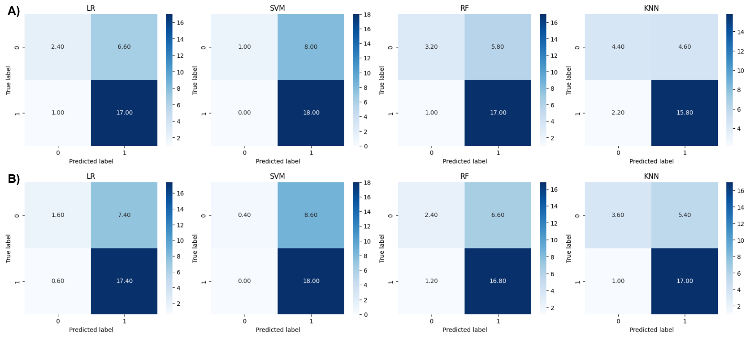
Figure S1: Confusion matrices of the EEG classifications.
(A) Alpha and (B) beta EEG classifications with LR, SVM, RF, and KNN classifiers.
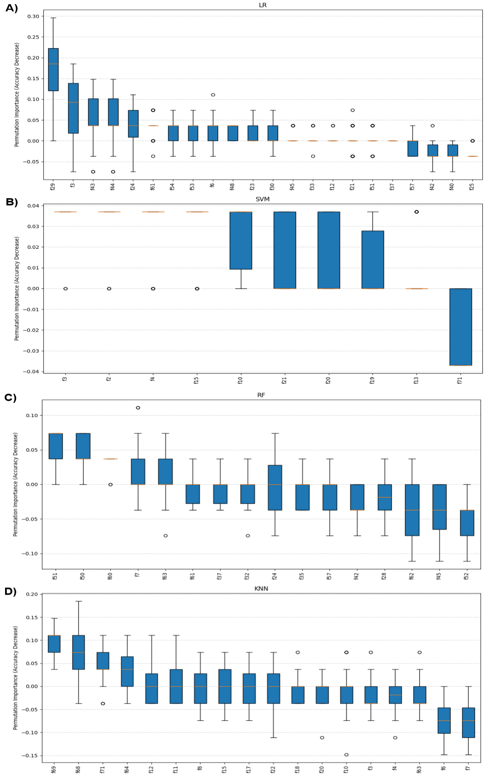
Figure S2: Feature importance plots for the classification of alpha T5 EEG.
(A) Alpha T5 EEG classification with LR, (B) SVM, (C) RF, and (D) KNN classifiers.

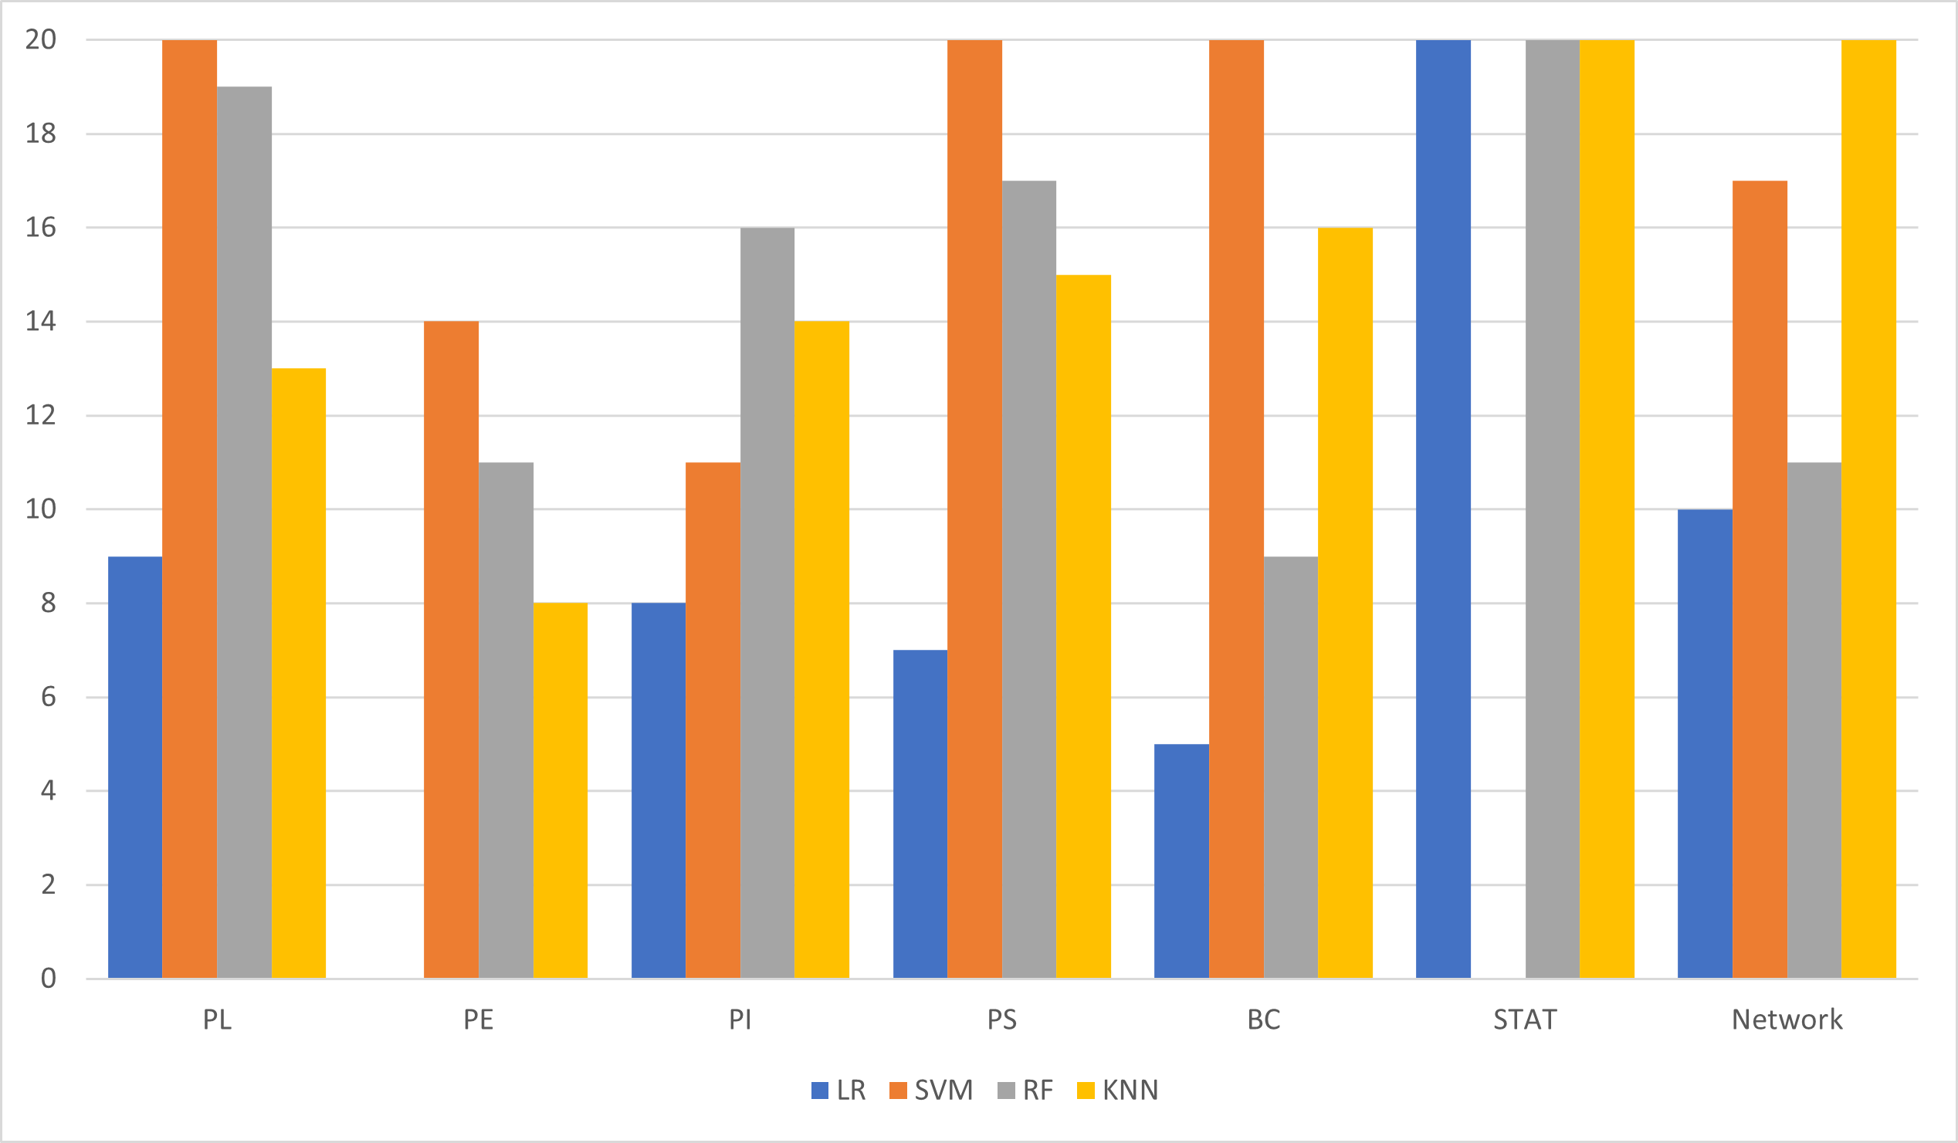
Figure S3: Features selected in T5 EEG signal classification with each classifier over 20 BPSO independent runs.

