As shown in Figures 1, 2, and 3, the performance of six CNV detection tools on the real datasets NA19238, NA19239, and NA19240 is illustrated.
For NA19238 and NA19240 (Figures 1 and 2), SOSCNV achieves noticeably higher precision than the other five tools, although its recall is slightly lower than that of SVision and RSICNV. Nevertheless, in terms of the overall performance, the F1-score of SOSCNV is only marginally lower than that of SVision, indicating competitive detection capability.
In the results for NA19240 (Figure 3), Manta attains the highest precision among all tools. However, due to the large number of CNVs provided by DGV as the ground truth, its F1-score does not remain correspondingly high. SVision also performs well on real data; however, it has notable limitations. It requires high-quality sequencing data and fails to produce stable results under low sequencing depth.

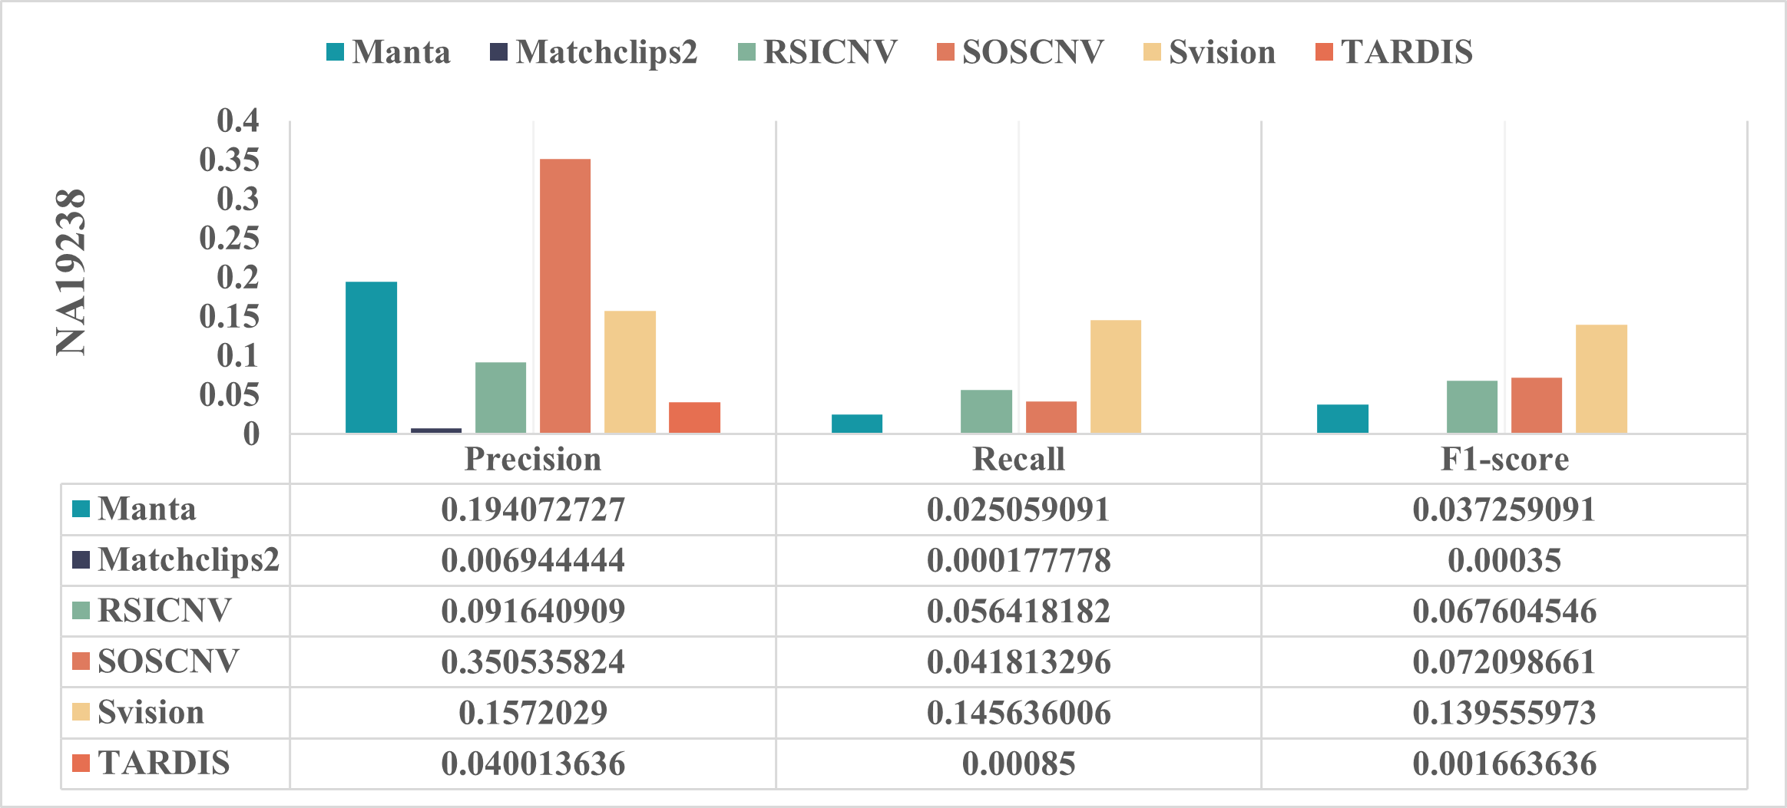
Figure 1. Detection performance of six CNV detection tools evaluated on the real NA19238 dataset.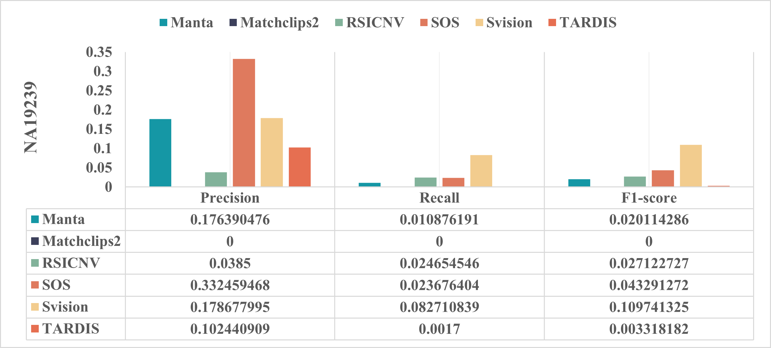
Figure 2. Detection performance of six CNV detection tools evaluated on the real NA19239 dataset.
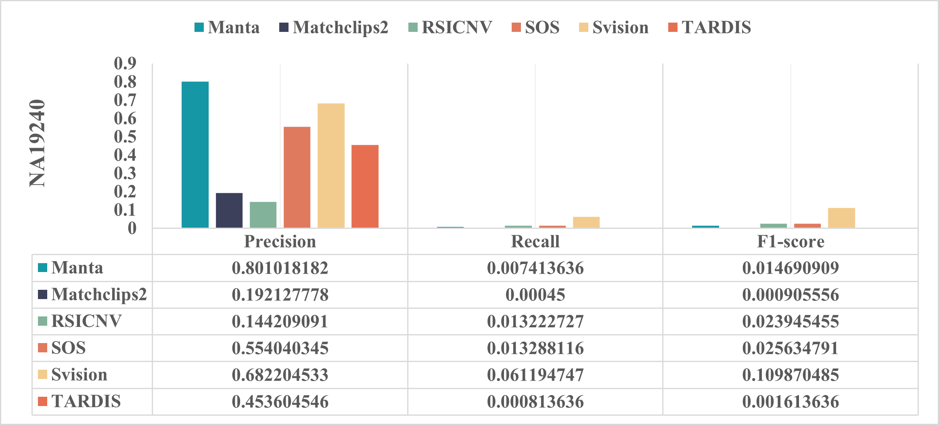
Figure 3. Detection performance of six CNV detection tools evaluated on the real NA19240 dataset.

